Supplementary Information – SI
to
Polycyclic Aromatic Hydrocarbons: Impact of municipal and industrial wastewater on river catchment water quality
Dominika Matuszewska ^{a, b, c*}, Edyta Kiedrzyńska ^{b, c**}, Marcin Kiedrzyński ^{d}, Maciej Zalewski ^{b}
ª Doctoral School of Exact and Natural Sciences, University of Lodz, Jana Matejki 21/23, 90-237 Lodz, Poland
^{b} European Regional Centre for Ecohydrology of the Polish Academy of Sciences, Tylna 3, 90-364 Lodz, Poland
^{c} University of Lodz, Faculty of Biology and Environmental Protection, UNESCO Chair on Ecohydrology and Applied Ecology, Banacha 12/16, 90-237 Lodz, Poland
^{d} University of Lodz, Faculty of Biology and Environmental Protection, Department of Biogeography, Paleoecology and Nature Conservation, Banacha 1/3, 90-237 Lodz, Poland
*d.matuszewska@erce.unesco.lodz.pl
**e.kiedrzynska@erce.unesco.lodz.pl
ORCID number: D.M.:0000-0002-3586-8155; E.K.:0000-0003-0649-4438; M.K.:0000-0002-1751-9357; M.Z.: 0000-0002-4483-6200
Table SI1 Structure of individual Polycyclic Aromatic Hydrocarbons
Name of the compound | Abbreviation | Structure
Naphthalene | NAP | 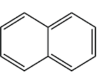
Acenaphthylene | ACY | 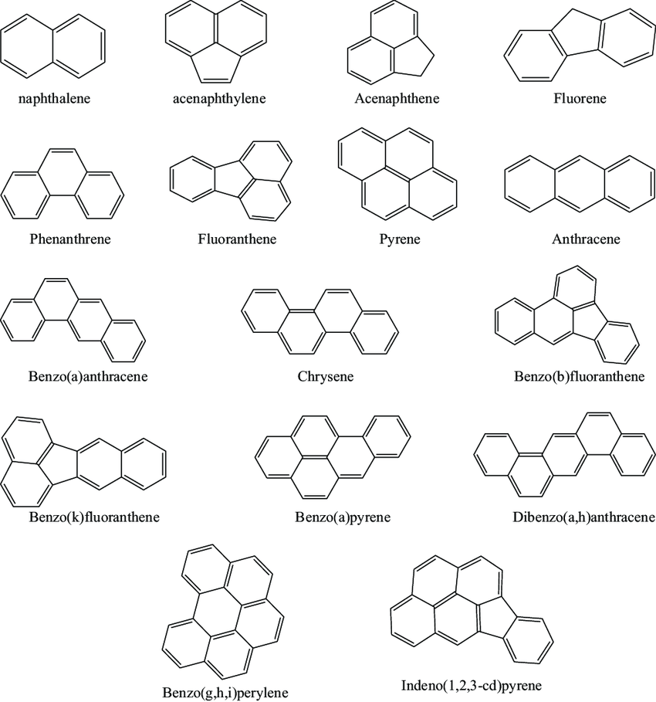
Acenaphthene | ACE
Fluorene | FLU
Phenanthrene | PHE
Anthracene | ANT
Fluoranthene | FLT
Pyrene | PYR
Benzo(a)anthracene | BaA
Chrysene | CHR
Benzo(a)pyrene | BaP
Benzo(b)fluoranthene | BbF
Benzo(k)fluoranthene | BkF
Dibenzo(a,h)anthracene | DahA
Indeno(1,2,3-c,d)pyrene | IP
Benzo(g,h,i)perylene | BghiP

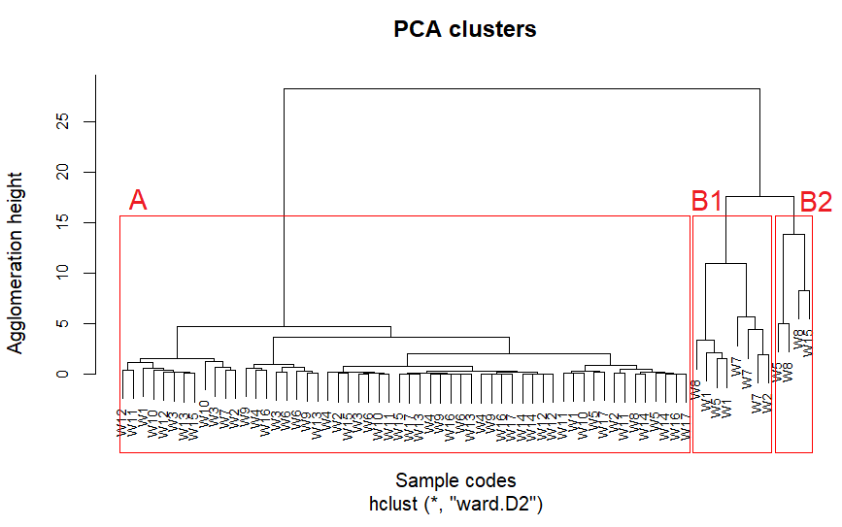
Figure SI1. Dendrogram of hierarchical clustering performed on the first four principal components (PCA) derived from 14 PAH variables in municipal wastewater samples. Clustering was carried out using the Ward.D2 method on Euclidean distances, and the three identified clusters are highlighted with red rectangles

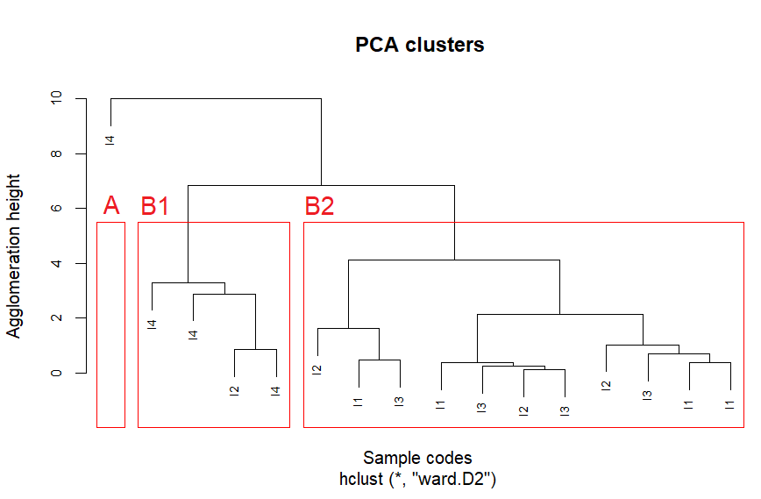
Figure SI2. Dendrogram of hierarchical clustering performed on the first three principal components (PCA) derived from 7 PAH variables in industrial wastewater samples. Clustering was carried out using the Ward.D2 method on Euclidean distances, and the three identified clusters are highlighted with red rectangles.
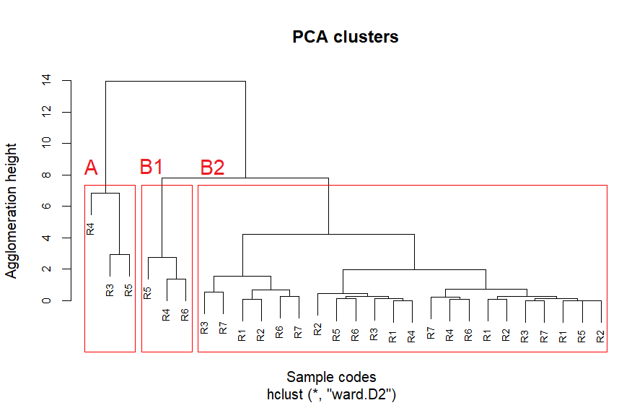
Figure SI3. Dendrogram of hierarchical clustering performed on the first three principal components (PCA) derived from 7 PAH variables in river water samples. Clustering was carried out using the Ward.D2 method on Euclidean distances, and the three identified clusters are highlighted with red rectangles.

