Polycyclic Aromatic Hydrocarbons: Impact of Municipal and Industrial Wastewater on River Catchment Water Quality
Dominika Matuszewska^{1,2,3, *}, Edyta Kiedrzyńska ^{2, 3, **}, Marcin Kiedrzyński ⁴, Maciej Zalewski ²
¹ Doctoral School of Exact and Natural Sciences, University of Lodz, Jana Matejki 21/23, 90-237 Lodz, Poland
² European Regional Centre for Ecohydrology of the Polish Academy of Sciences, Tylna 3, 90-364 Lodz, Poland
³ University of Lodz, Faculty of Biology and Environmental Protection, UNESCO Chair on Ecohydrology and Applied Ecology, Banacha 12/16, 90-237 Lodz, Poland
⁴ University of Lodz, Faculty of Biology and Environmental Protection, Department of Biogeography, Paleoecology and Nature Conservation, Banacha 1/3, 90-237 Lodz, Poland
*d.matuszewska@erce.unesco.lodz.pl
**e.kiedrzynska@erce.unesco.lodz.pl
ORCID number: D.M.:0000-0002-3586-8155; E.K.:0000-0003-0649-4438; M.K.:0000-0002-1751-9357; M.Z.: 0000-0002-4483-6200
Abstract
Due to the environmental threat posed by polycyclic aromatic hydrocarbons (PAHs), these compounds are included on the priority substance lists of both the U.S. EPA and the European Union. Monitoring their sources is therefore crucial for protecting aquatic ecosystems.
This study presents a comprehensive analysis of the PAH content of municipal and industrial wastewater and its transport and distribution along the Pilica River continuum, the largest left-bank tributary of the Vistula River. The highest PAH loads to the Pilica River were discharged by class IV municipal wastewater treatment plants (WWTPs); this was related to the volume of WWTP outflow, and the composition of treated wastewater, which was dominated by phenanthrene (PHE), pyrene (PYR) and naphthalene (NAP). Among industrial sources, the fruit and vegetable processing sector contributed the most PAHs, while the furniture sector showed the greatest variation in PAH composition.
Despite the large PAH loads carried along the Pilica river continuum, none of the identified concentrations in the tested samples exceeded the standards contained in Directive 2013/39/EU of the European Parliament and Council. Furthermore, among all sample types, the emission of PAH loads peaked in the autumn-winter period; the samples also demonstrated common correlation patterns, indicating common sources and similar environmental properties.
A key innovation of the study is its holistic approach, i.e. it treats the entire river basin as a unified research system. This perspective enables better understanding of PAH transport, retention, and degradation processes, which are essential for assessing ecological risk and developing effective pollution management strategies.
Key words: PAHs, wastewater, municipal wastewater treatment plants, industrial plants, Pilica River catchment, Ecohydrology
Graphical Abstract 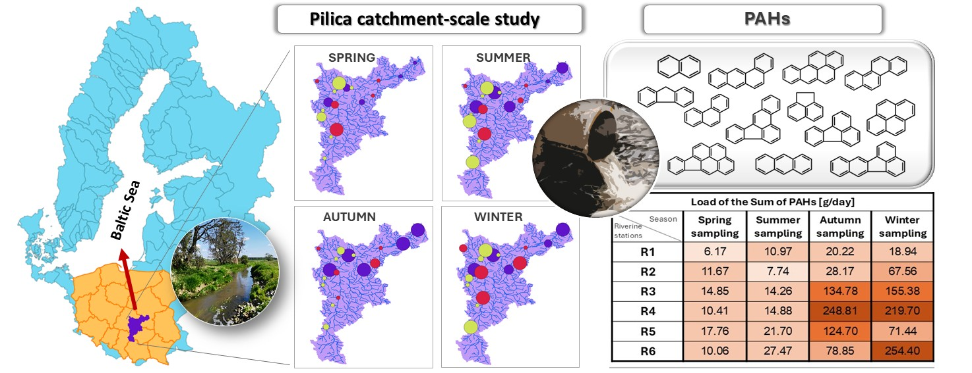
Contents
1. Introduction 4
2. Materials and methods 7
2.1 Characteristics of the case study 7
2.2 Monitoring stations of riverine water and wastewater quality 8
2.3 Physical and chemical analysis 12
2.4 Analysis of PAHs in water and wastewater 13
2.5 Statistical analysis 14
3. Results 15
3.1 Municipal wastewater quality in the catchment 15
3.2 Industrial wastewater quality in the catchment 24
3.3 Riverine water quality along the river continuum 30
4. Discussion 35
4.1 PAHs in municipal wastewater 36
4.2 PAHs in industrial wastewater 39
4.2.1 Dairy industry 39
4.2.2 Fruit and vegetable industry 39
4.2.3 Furniture industry 40
4.3 PAHs in river water 41
5. Legal regulations regarding PAHs 45
6. Biological methods for eliminating PAHs from the environment 46
6.1 Bioremediation 47
6.2 Phytoremediation 49
7. Conclusions 50
8. Acknowledgements 51
9. References 52

- Introduction
Sewage is characterized by high levels of organic pollutants of anthropogenic origin and a highly-complex matrix, making one of the most serious threats to surface waters and human health (Huang et al., 2020). In 2013, annual wastewater production was estimated at 330 billion m³, with most of it deriving from municipal sources; by 2015, this value had increased to 360–380 billion m³ (United Nations Environment Programme, 2023). In 2022 alone, global domestic sewage production amounted to 268 billion m³, of which only 58% was delivered to treatment plants and safely treated; of the remainder, 45% was derived from a lack of sewer connections or septic tanks, 24% resulted from inadequate emptying of tanks or subjecting sewage only to pre-treatment, and 19% was obtained from systems that failed to meet standards for discharge (The United Nations Human Settlements Programme, 2024). Despite the apparent decline in wastewater production, it is estimated that by 2030, the volume of municipal and domestic wastewater will increase to 470–497 billion m³ annually (United Nations Environment Programme, 2023).
One group of organic anthropogenic pollutants known to frequently occur in the environment is the polycyclic aromatic hydrocarbons (PAHs): compounds consisting of at least two aromatic rings connected by two common carbon atoms (Bojakowska, 2003). They can enter aquatic ecosystems from anthropogenic sources, such as oil spills, industrial discharges, shipping activities, storm sewers and municipal sewage (Sukhdhane et al., 2019), and combustion of fossil fuels and waste, and natural sources, such as volcanic eruptions or forest fires (Mawad et al., 2021). However, it is anthropogenic sources that are primarily responsible for significant PAH emissions into the environment. In 2007, global PAH atmospheric emissions were estimated at 504 Gg, with the largest contributions being made by residential and commercial biomass combustion (60.5%), open-air biomass combustion (including agricultural waste burning, deforestation, and forest fires – 13.6%), and petroleum consumption by road vehicles (12.8%) (Shen et al., 2013). Roughly half of global emissions were produced by regions with the highest emission densities: South Asia (87 Gg), East Asia (111 Gg), and Southeast Asia (52 Gg). Of these emissions, 6.19% consisted of carcinogenic high molecular weight PAHs (HMWPAHs), with a higher proportion noted in developing countries (6.22%) compared to developed countries (5.73%), reflecting differences in energy structures and technological levels (Shen et al., 2013). Moreover, in 2015 alone, global anthropogenic PAH emissions amounted to 304 Gg (Li et al., 2022). Anthropogenic activities have been found to influence PAH emission to the environment in various scenarios, including the Elbe River, where COVID-19 lockdown measures resulted in a reduction in human activities: during the three lockdowns that took place in Germany, the percentage of PAHs adsorbed on suspended particulate matter in the river declined by up to -18 %, and then rebounded by up to 29 %, compared to previous years, after the restrictions were lifted (Li et al., 2024).
Studies have found PAHs to have widespread occurrence, hydrophobicity and high resistance to degradation (Patel et al., 2019; Cai et al., 2019), as well as potential mutagenic and carcinogenic properties (Feng et al., 2012); as such, their presence represents a considerable threat to the environment.
The biodegradability of PAHs is closely related to their structure: compounds with a larger number of aromatic rings undergo slower, more complex biodegradation processes. Furthermore, the decomposition processes is also limited by the type and number of functional groups, and thus the number of enzymatic attacks that must occur to separate these groups (Piwowarska & Kiedrzyńska, 2022). Importantly, exposure of PAHs to light leads to the formation of partially-oxidized intermediates, which may be more susceptible to biodegradation. However, it should be noted that some short-lived metabolites formed during degradation may exhibit higher toxicity, mutagenicity and carcinogenicity than the parent compounds (Malakahmad et al., 2016). Moreover, PAHs are emitted into the atmosphere as mixtures, increasing their toxicity to the environment (Barbosa et al., 2023).
Due to their high potential for harm, 16 PAHs have been included in the lists of priority substances for routine monitoring of soil, air and water specified by the United States Environmental Protection Agency and the European Union (Barbosa et al., 2023). These sixteen include both low-molecular-weight and high-molecular-weight PAHs. The low-molecular-weight group includes bicyclic (naphthalene) and tricyclic compounds, such as acenaphthylene, acenaphthene, fluorene, phenanthrene and anthracene (Tab. SI1). Other compounds include larger numbers of rings, such as tetracyclic PAHs (fluoranthene, pyrene, benzo(a)anthracene, chrysene), pentacyclic PAHs (benzo(a)pyrene, benzo(b)fluoranthene, benzo(k)fluoranthene, dibenzo(a,h)anthracene) and hexacyclic PAHs (indeno(1,2,3-c,d)pyrene, benzo(g,h,i)perylene) (Tab. SI1). PAHs with larger numbers of rings are characterized by lower acute toxicity, but much higher carcinogenic potential (HELCOM, 2018).
Although the negative effects of polycyclic aromatic hydrocarbons (PAHs) entering the environment are well documented, the identification of their sources and the assessment of their seasonal variations at the catchment scale remain unclear. The majority of studies have focused mainly on individual emission points or selected river sections, which prevents a comprehensive understanding of PAH transport and transformation processes in aquatic environments. There is also a lack of comprehensive analyses considering different land-use types, hydrological variability, and the influence of anthropogenic processes on PAH dynamics. Hence, there is a need for systematic catchment-scale studies to accurately evaluate source contributions and to better understand the mechanisms controlling the seasonal variability of PAHs, which is crucial for ensuring effective surface water quality management and reducing ecological risks. As direct point sources represent one of the most dangerous sources of toxic substances in the environment, it is important that they are monitored to protect aquatic ecosystems. Therefore, the aim of this article is to conduct a comprehensive, holistic analysis of municipal and industrial wastewater for the presence of polycyclic aromatic hydrocarbons (PAHs) and to determine the process of their transport and distribution along the Pilica river continuum, one of the largest rivers in Poland. An innovative aspect of the presented work is that it includes the entire river basin in the analysis as an integral system; this approach allows for a better understanding of the complex physicochemical and biological processes affecting the migration, retention and degradation of PAHs in the aquatic environment. The obtained data are of great importance for the assessment of ecological risk and the development of effective pollution management strategies in the basin.
- Materials and methods
  - Characteristics of the case study
The Pilica River, the largest left-bank tributary of the Vistula River, extends over 342 km. It flows through southern and central Poland, traversing several physiographic regions: the upper part of its catchment area (360–180 m a.s.l.) is located within the Kraków-Częstochowa Upland and the Przedbórz Upland, while the lower section (95–170 m a.s.l.) lies within the Mazovian Lowland (Koniuszewska et al., 2020). Its catchment, situated in central Poland, encompasses a total area of 9,258 km² (Szklarek et al., 2021).
Within the Pilica River basin, arable land predominates, accounting for 39.6% of the total area and consisting of mainly winter and spring cereal crops. This is followed by forest, occupying approximately 38.6% of the basin. Urbanized areas, in contrast, represent less than 4% of the total catchment area (Izydorczyk et al., 2019). The morphometric diversity of the terrain results in variable specific runoff rates, ranging between 3 and 6 L/s/km². The river is fed by 19 tributaries and flows through twelve urban centers: Szczekociny, Koniecpol, Przedbórz, Sulejów, Tomaszów Mazowiecki, Piotrków Trybunalski, Spała, Inowłódz, Nowe Miasto, Wyśmierzyce, Białobrzegi, and Warka. Among them, Tomaszów Mazowiecki is notable by its significant industrial activity, including textile, ceramic, machinery, metal, and leather manufacturing sectors, whereas Warka has a well-developed brewing and fruit-vegetable processing industries (Urbaniak et al., 2014).
The basin encompasses 143 municipal wastewater treatment plants, which collectively serve approximately 59% of the population and produce a mean discharge of 18 341 875 m³ of wastewater per year. Domestic and industrial wastewater contribute 4% and 8%, respectively, to the total volume of discharged effluents. (Kiedrzyńska et al., 2014). The river system is also under further anthropogenic pressure from the presence of numerous industrial facilities throughout the basin (Szklarek et al., 2021; Kiedrzyńska et al., 2014).

2.2 Monitoring stations of riverine water and wastewater quality
Samples were collected at 28 sites: 17 wastewater treatment plants, 4 industrial plants and 7 points on the river (Fig.1). The selection of wastewater treatment plants was intended to represent both the spatial distribution across the catchment and variability in the RLM index, while the river water sampling locations were chosen to cover the full extent of the river continuum. The municipal sewage treatment plants (WWTPs) were divided in terms of population equivalent (P.E.) into class I (0-1,999), class II (2,000-9,999) and class IV (15,000-99,999). Additionally, samples of treated sewage were collected directly from the outflows of 4 industrial plants (I 1- I4) representing the dairy industry (I1), fruit and vegetable industry (I2, I3) and furniture industry (I4) (Tab.1).
Water quality of the Pilica River was monitored along its continuum, i.e. from the source to the mouth (R1-R7). Samples were taken from bridges (sites R1, R2, R4, R5, R6, R7) and from a site located just below the Sulejowski Reservoir dam (R3). River monitoring sites R1-R6 were selected in locations where existing water gauges belonging to the Polish Institute of Meteorology and Water Management were located.
Sampling points were also located throughout the catchment area. Sampling was carried out in the years 2022-2023 in seasonal cycles, viz. spring (09-10.05.2022), summer (18-19.07.2022), autumn (05-06.12.2022), winter (27-28.02.2023). In total, 68 samples of treated sewage were taken from municipal sewage treatment plants and 16 from industrial plants, and 28 samples of river water were taken from the Pilica River. All were then subjected to physicochemical analyses.
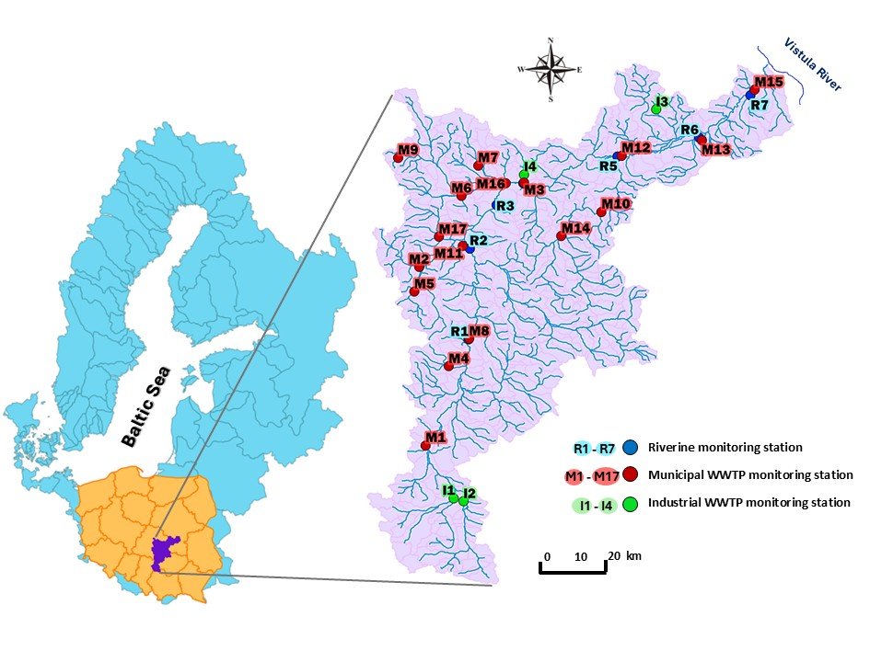
Fig.1 Locations of the Pilica River catchment (central Poland), WWTP monitoring stations (M1–M17), industrial plants (I1-I4) and riverine monitoring stations (R1–R7) along the Pilica River continuum.
Tab.1 Characteristics of the monitored municipal and industrial WWTPs in the Pilica River catchment.
Municipal WWTP monitoring stations
Station | Location of WWTPs | WWTP size class | Population equivalent of WWTPs | Mean wastewater outflow in m³/day from WWTPs
M1 | Koniecpol | I | 600 | 447.3
M2 | Rozprza | I | 500 | 101.0
M3 | Spała | I | 350 | 103.5
M4 | Wielgomłyny | I | 1000 | 67.0
M5 | Gorzkowice | I | 700 | 425.9
M6 | Wolbórz | I | 800 | 399.0
M7 | Ujazd | I | 1500 | 628.3
M8 | Przedbórz | II | 2000 | 839.5
M9 | Tuszyn | II | 4000 | 788.0
M10 | Drzewica | II | 6000 | 828.3
M11 | Sulejów | II | 7500 | 1613.8
M12 | Nowe Miasto nad Pilicą | II | 2583 | 217.3
M13 | Białobrzegi | IV | 58400 | 2148.5
M14 | Opoczno | IV | 75000 | 4405.3
M15 | Warka | IV | 99000 | 4187.5
M16 | Tomaszów Mazowiecki | IV | 80000 | 9736.0
M17 | Piotrków Trybunalski | IV | 80000 | 10243.0
Industrial plant monitoring stations
 | Location of industrial plant | Type of industry |  | Mean wastewater outflow in m³/day from industrial plants
I2 | Szczekociny | dairy industry |  | 146.75
I1 | Szczekociny | fruit and vegetable industry |  | 589.25
I3 | Kozietuły Nowe | fruit and vegetable industry |  | 1533.53
I4 | Inowłódz | furniture industry |  | 32.5
Riverine monitoring stations
Station | Town name of a station | Station type in the  river continuum | Km of the river (from the estuary) | Mean river discharge [m³/s]
R1 | Przedbórz | River | 201.2 | 15.02
R2 | Sulejów | River (inflow to Sulejów Reservoir) | 161.3 | 21.48
R3 | Smardzewice | Sulejów Reservoir (outflow) | 136.3 | 26.58
R4 | Spała | River | 119.4 | 31.35
R5 | Nowe Miasto | River | 78.8 | 34.65
R6 | Białobrzegi | River | 45.3 | 42.05
R7 | Warka | River | 17.0 | no data

2.3 Physical and chemical analysis
The samples were tested in situ for the following physical parameters using a YSI-6050000 Professional Plus multiparameter meter: water temperature, pH, specific conductivity (SPC), total dissolved solids (TDS), salinity, dissolved oxygen, and redox potential (ORP).
The samples were then transported to the laboratory under refrigerated conditions (5°C) and subjected to further analyses. For ion analysis, the samples were filtered through GF/F filters and subjected to ion chromatography (DIONEX, ICS 1000) for the following ions: fluoride (F¯), chloride (Cl¯), bromate (Br¯), nitrate (NO₃¯), phosphate (PO₄³¯), sulfate (SO₄²¯), lithium (Li⁺), ammonium (NH₄⁺), sodium (Na⁺), potassium (K⁺), magnesium (Mg²⁺), and calcium (Ca²⁺).
Total suspended solids (TSS) was determined for each sample by filtering a known water volume (V) through pre-weighed Whatman GF/F filters. The filters were then dried at 105°C for approximately 1.5 hours and reweighed using a Mettler electronic balance to calculate the mass of the retained solids.
Unfiltered surface water and treated wastewater samples were analyzed for total phosphorus (TP) using the ascorbic acid method with an oxidative decomposition reagent (Oxisolv, Merck) and a microwave digestion system (Merck MV500), as described by Kiedrzyńska et al. (2014).
Total nitrogen (TN) concentrations were determined using commercially-available test kits (method 10071, TNT, Hach), with a measurement range of 0–25 mg/L.
Chemical oxygen demand (COD) was assessed using an AQUALYTIC® COD VARIO photometer and commercial cuvette tests with a range of 0–1500 mg/L (Tintometer GmbH). The samples were digested in an AL125 thermoreactor and analyzed according to the manufacturer’s instructions.
The biochemical oxygen demand (BOD₅) in treated wastewater and surface water was measured by respirometry using the Lovibond BD 600 measurement system (Tintometer Group). The samples were incubated for five days in hermetically-sealed bottles with sensor-equipped heads; the system automatically calculated BOD₅ values based on pressure changes monitored during incubation. Samples were kept in darkness at 21°C in a Pol-ST3 Basic thermostatic chamber (POL-EKO).

2.4 Analysis of PAHs in water and wastewater
The samples were assayed for 15 PAHs: acenaphthene (ACE), anthracene (ANT), benzo(a)anthracene (BaA), benzo(a)pyrene (BaP), benzo(b)fluoranthene (BbF), benzo(k)fluoranthene (BkF), chrysene (CHR), phenanthrene (PHE), fluoranthene (FLT), fluorene (FLU), indeno(1,2,3-cd)pyrene (IP), naphthalene (NAP), pyrene (PYR), benzo(ghi)perylene (BghiP) and dibenzo(a,h)anthracene (DahA). The results were used to calculate the sum of PAH (PAH SUM). All analyses were performed using liquid chromatography with a fluorescence detector (LC-FLD) in accordance with the PN-EN ISO 17993:2005 standard by an accredited analytical laboratory. The limits of quantification (LOQs) for the analysed PAHs were as follows: 0.03 µg/L for acenaphthene (ACE) and naphthalene (NAP); 0.003 µg/L for anthracene (ANT), benzo(a)anthracene (BaA), benzo(a)pyrene (BaP), benzo(k)fluoranthene (BkF), chrysene (CHR), phenanthrene (PHE), indenol(1,2,3-cd)pyrene (IP), and pyrene (PYR); and 0.006 µg/L for benzo(b)fluoranthene (BbF), fluoranthene (FLT), fluorene (FLU), benzo(ghi)perylene (BghiP), and dibenzo(a,h)anthracene (DahA). As benzo(ghi)perylene, dibenzo(a,h)anthracene were not detected in any sample, they were not included in the analyses.
  - Statistical analysis
The data points were independent from each other, and their distributions were not normal (Shapiro–Wilk test). Correlations between PAH concentrations (acenaphthene, anthracene, benzo(a)anthracene, benzo(a)pyrene, benzo(b)fluoranthene, benzo(k)fluoranthene, chrysene, phenanthrene, fluoranthene, fluorene, indeno(1,2,3-cd)pyrene, naphthalene, pyrene and sum of PAH) and other physico-chemical factors were determined using Spearman’s test.
Water and wastewater PAH concentration data were imported and pre-processed in R (R Core Team, 2024) using the readr package (Wickham et al., 2023). Samples were filtered to retain only the target group, and non-numeric measurements were coerced to numeric, with any variables exhibiting zero variance removed. Pairwise correlation structure among the remaining PAH variables was assessed and visualized using corrplot (Wei & Simko, 2021) to identify potential multicollinearity.
Dimensionality reduction via principal component analysis (PCA) was carried out on the standardized PAH dataset; the proportion of variance explained by each principal component was then extracted and plotted with factoextra (Kassambara & Mundt, 2020) to guide the number of components retained. Results were visualized in two-dimensional biplots, combining sample ordination and variable loadings, using ggplot2 (Wickham, 2016) with non-overlapping label placement provided by ggrepel (Slowikowski et al., 2021).
Clusters were delineated by applying hierarchical agglomerative clustering to the principal component scores retained based on a cumulative variance threshold of 85% (Kassambara & Mundt, 2020). Euclidean distances among samples in this reduced PCA space were computed and used with the Ward D2 linkage criterion to form a dendrogram (Murtagh & Legendre, 2014). The optimal number of clusters was then determined by visual inspection of the dendrogram and confirmed via silhouette analysis (Kassambara & Mundt, 2020), and final cluster memberships were assigned by cutting the tree at the chosen height using the stats package (R Core Team, 2024).
A chart illustrating the median PAH concentrations entering the Pilica River from various sources (Fig.2) was created using Statistica ver. 13.3 (StatSoft Poland). Data below the quantification limit were included in the analysis, in accordance with Article 5 of Commission Directive 2009/90/EC of 31 July 2009 establishing, under Directive 2000/60/EC of the European Parliament and of the Council, technical specifications for the analysis and monitoring of chemical water – LOQ/2. Similar assumptions were made by Gracia-Lor (2020).
The PAH ratios illustrating potential sources of PAH emissions in industrial plants were identified based on Tobiszewski and Namieśnik (2012).
- Results

3.1 Municipal wastewater quality in the catchment
The median values ​​of the analyzed PAHs concentrations differ between individual compounds, but no significant differences were found between the median concentrations and the groups of samples, viz. small, medium or large municipal WWTPs, industrial WWTPs and river water (Fig. 2A,B). The greatest differentiation among the medians were found for PHE and FLT, with the highest median value identified among samples from small WWTPs. Among the WWTPs, the lowest median concentration was found for PYR, which was noted in the large WWTPs (Fig.2B).
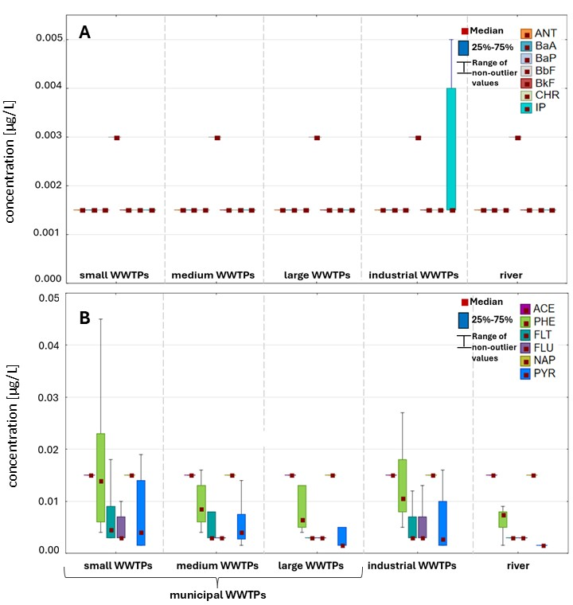
Fig.2 Median PAH concentrations identified in the treated municipal wastewater (small, medium, large- size WWTPs) throughout the sampling period (May 2022-Feb.2023) compared to the output of the industrial wastewater plants and the riverine water. A. anthracene (ANT), benzo(a)anthracene (BaA), benzo(a)pyrene (BaP), benzo(b)fluoranthene (BbF), benzo(k)fluoranthene (BkF), chrysene (CHR), indeno(1,2,3-cd)pyrene (IP); B. acenaphthene (ACE), phenanthrene (PHE), fluoranthene (FLT), fluorene (FLU), naphthalene (NAP), pyrene (PYR)
PCA analysis was used to present spatial and temporal patterns of pollutant occurrence based on normalized data on PAH concentrations detected in the analyzed seasons. The results arrange all WWTPs along the PCA1 axis, which explains 48% of the variability. In turn, the PCA2 axis explains 22.3%. PCA ordination did not indicate any significant seasonal relationships between the analyzed samples and PAH content, which may also be influenced by the nature of the sample group (Fig.3A). Most of the samples are located on the opposite side of the PCA1 axis than the arrowheads indicating PAHs.
Clustering by wastewater treatment plant size divided the analyzed samples into three groups and clearly indicated a relationship between the analyzed compounds and small wastewater treatment plants. The upper right quadrant included seven small WWTPs and one medium-sized wastewater treatment plant (ellipse B1 – determined based on the dendrogram in Fig. SI1). This group is correlated with the concentrations of ACE, NAP, FLU, ANT, PHE, FLT, and PAH SUM. The lower right quadrant contains ellipse B2, which identifies a group of two medium-sized WWTPs as well as one large and one small wastewater treatment plant (Fig. 3B). This group is correlated with CHR, BbF, BaA, BaP, IP, and BkF. The dendrogram used to determine the ellipses is provided in the Supplementary Information (Fig. SI1).
The variation in the obtained results is related to the nature of the analyzed samples and the wastewater treatment plants generating them. Small WWTPs within the catchment area receive sewage via sewage suction trucks, which results in high contaminant loads being delivered to the plants at one time. Furthermore, the Pilica catchment area is rich in industrial plants, from which sewage also reaches the wastewater treatment plants.
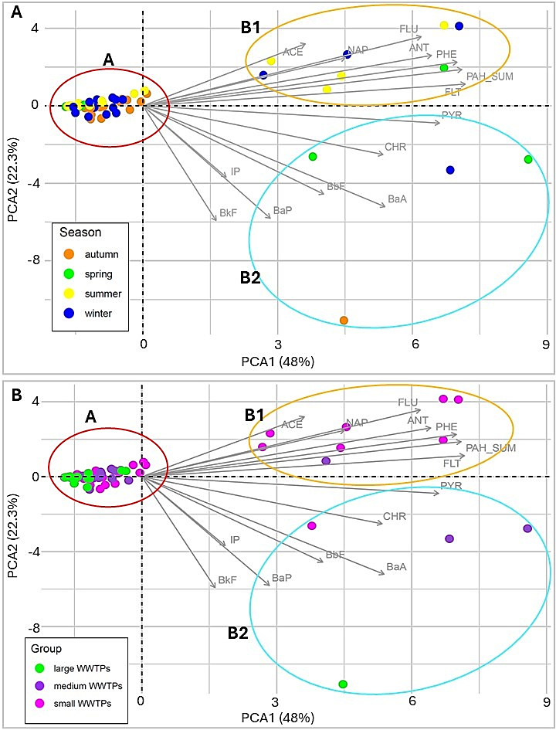
Fig.3 PCA score plot for municipal wastewater samples, coloured by season (A) and WWTPs group (B). PCA cluster membership marked by ellipses. The corresponding hierarchical dendrogram is provided in the Supplementary Information (Fig. SI1).; A: green dot – spring, yellow dot – summer, orange dot – autumn, blue dot – winter; B: pink dot – small WWTPs, violet dot – medium WWTPs, green dot – large WWTPs.
Spearman’s correlation analysis was performed to identify the physicochemical factors influencing the total PAH levels detected in treated wastewater. The results indicate that conductivity, TDS, salinity, flow, suspended solids, TN and TP concentrations, BOD₅ and COD values, and also F⁻ PO₄³⁻ and SO₄²⁻ ion content had a significant influence on PAH concentrations from municipal wastewater treatment plants (Fig.4). More specifically, the highest correlations with physicochemical factors were demonstrated for phenanthrene (PHE) and indeno(1,2,3-cd)pyrene (IP). For PHE, significant negative correlations were demonstrated with flow, Li⁺, NO₃⁻ and SO₄²⁻ ion concentration, and positive correlations with TSS, TN, TP, BOD₅ and COD. For IP, negative correlations were observed for temperature, pH and Mg ²⁺, and positive correlations for oxygen, ORP, turbidity, suspended solids, BOD₅, COD and F⁻ (Fig.4). These findings suggest that PAHs tend to co-occur with classic indicators of organic and biogenic pollution, which would confirm their anthropogenic origin (including wastewater). However, TSS plays an important role in the transport and retention of PAHs, as they can adsorb on solid particles. Moreover, the lack of any strong correlations with physical parameters (T, pH, O₂) suggests that their spread depends mainly on the chemical composition of water and the source of emission.
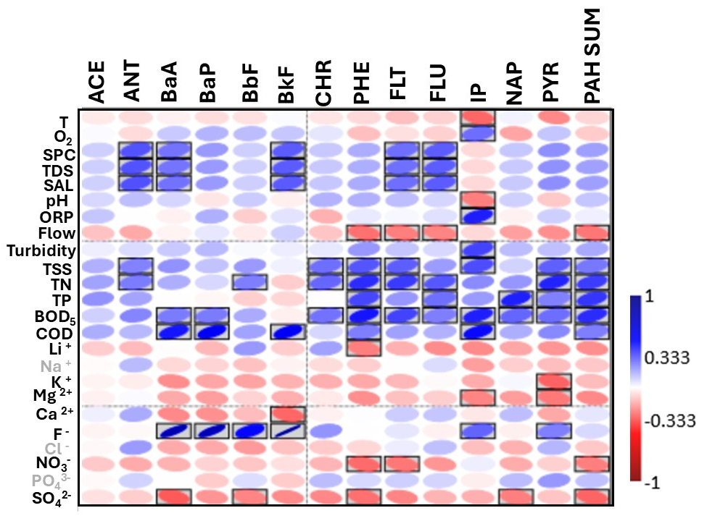
Fig.4 Spearman’s correlation matrix between PAH concentrations in treated sewage from municipal wastewater treatment plants and physico-chemical parameters. Statistically-significant values (p>0.05) are marked in frames. Acenaphthene (ACE), anthracene (ANT), benzo(a)anthracene (BaA), benzo(a)pyrene (BaP), benzo(b)fluoranthene (BbF), benzo(k)fluoranthene (BkF), chrysene (CHR), phenanthrene (PHE), fluoranthene (FLT), fluorene (FLU), indeno(1,2,3-cd)pyrene (IP), naphthalene (NAP), pyrene (PYR). The physico-chemical factors demonstrating significant correlations are highlighted in black.
Analysis of the total PAH content generated in the Pilica River catchment area according to WWTP class identified the highest mean daily loads to occur during summer in small WWTPs (74.38 mg/day), during winter in medium WWTPs (127.77 mg/day), and during autumn in large WWTPs (235.22 mg/day). The Min and Max values represent the highest and lowest estimated loads recorded for individual WWTPs; the analysis suggests that the highest loads were generated in autumn from one of the large WWTPs (503.47 mg/day) (Tab.2).
The smallest loads, regardless of WWTP class, were generated in spring (Fig.5A), and the highest loads (above 100 mg/day) were observed in winter (Fig.5D). It is important to note that the estimated loads are the result of daily sewage outflows, and the mean daily loads were obtained by averaging data from all the WWTPs located in a given class. The mean daily flows in the analyzed class IV WWTPs were 5890.5 m³/day in spring, 5730.9 m³/day in summer, 6401.0 m³/day in autumn, and 6553.9 m³/day in winter. For comparison, the mean flows were 357.7 m³/day (spring), 277.2 m³/day (summer), 262.7 m³/day (autumn), 343.4 m³/day (winter) in class I WWTPs, and 772.4 m³/day in spring, 819.0 m³/day in summer, 743.8 m³/day in autumn, and 1094.2 m³/day in winter in class II WWTPs (Tab.2).
In summary, the studies show that large WWTPs are the main point sources of PAH emissions in the catchment. Additionally, PAH emissions from sewage vary between seasons, with the highest values ​​observed in autumn and winter; this may be related to hydraulic load, temperature, as well as other operating conditions of the treatment plant. The size of the treatment plant is not the only factor determining the level of PAH emissions from sewage, because the location of the source of PAH emission, their inflow to the treatment plant, and local technological and operational conditions of the treatment plant also play a role. For comparison, the municipal and industrial levels are both provided in Table 2.
Tab.2 Summary of seasonal estimated average, minimum and maximum loads [mg/day] of the Sum of PAHs generated from individual groups (small, medium size and large) of wastewater treatment plants located in the Pilica River catchment (central Poland). Since the calculated loads are a function of both concentrations and flow rates, the final results are influenced by the number of measurements below the LOQ.
Total PAH load [mg/day]
Season | Daily PAHs load / Mean daily outflow of wastewater | Small WWTPS | Medium WWTPs | Large WWTPs | Industrial plants
Spring | Mean load [mg/day] | 45.90 | 69.11 | 37.86 | 6.54
Spring | Min load [mg/day] | 0.24 | 1.85 | 9.11 | 0.72
Spring | Max load [mg/day] | 235.04 | 287.35 | 71.76 | 16.48
 | Mean daily flow [m³/day] | 357.71 | 772.40 | 5890.46 | 585.03
Summer | Mean load [mg/day] | 74.38 | 73.39 | 87.12 | 8.89
Summer | Min load [mg/day] | 1.34 | 2.15 | 10.81 | 1.99
Summer | Max load [mg/day] | 183.89 | 249.00 | 130.00 | 20.46
 | Mean daily flow [m³/day] | 277.21 | 819.00 | 5730.88 | 516.50
Autumn | Mean load [mg/day] | 13.93 | 28.49 | 235.22 | 18.47
Autumn | Min load [mg/day] | 1.10 | 11.90 | 115.94 | 2.14
Autumn | Max load [mg/day] | 40.50 | 60.14 | 503.47 | 35.85
 | Mean daily flow [m³/day] | 262.71 | 743.80 | 6401.00 | 779.63
Winter | Mean load [mg/day] | 57.06 | 127.77 | 169.03 | 11.37
Winter | Min load [mg/day] | 0.90 | 13.12 | 53.13 | 1.76
Winter | Max load [mg/day] | 163.50 | 333.79 | 409.73 | 33.56
 | Mean daily flow [m³/day] | 343.43 | 1094.20 | 6553.86 | 420.88

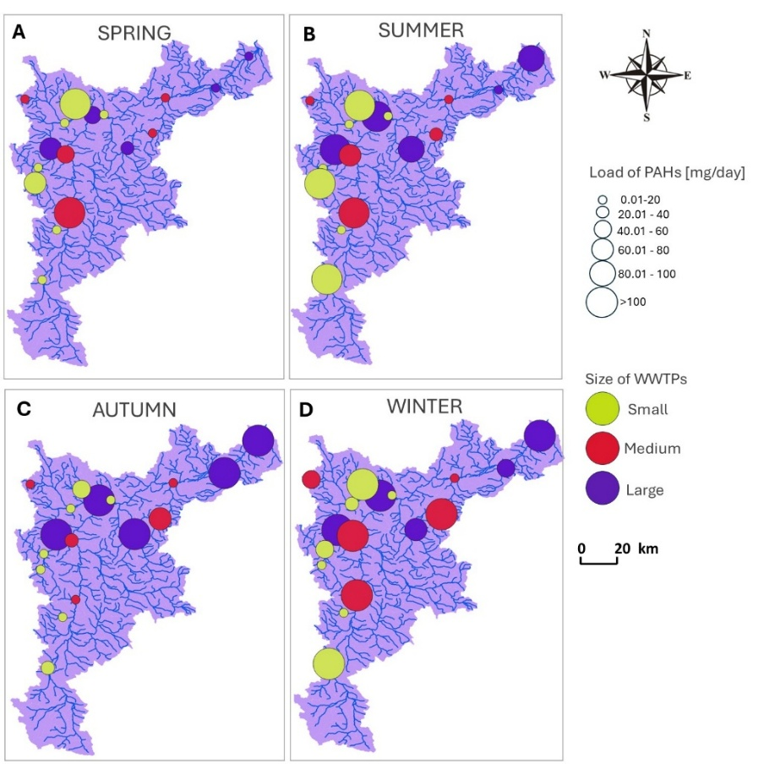
Fig.5 Daily mean total sum of PAHs loads [mg/day] released with treated wastewater from municipal wastewater treatment plants during the analyzed study period.
The most diverse PAH content could be observed in samples of treated wastewater from medium WWTPs in winter, although high diversity could also be observed in autumn in samples from large WWTPs. The most common compound found in the samples was phenanthrene, which in constituted a significant percentage of PAHs in all samples (Fig.6). The least PAH diversity was observed in sewage samples from large WWTPs in spring. The largest share of the total PAH content was PHE, which constituted 90% of the total PAH load in wastewater from all analysed class IV WWTPs; the remaining 10% was made up by PYR. Lower PAH diversity was also observed in summer, during which the PHE load constituted 84% of the total PAH load in all analysed samples from large WWTPs, the remainder being PYR (11% of total PAH load) and FLT (5%) (Fig. 6).
In summary, the PAH composition is dominated by compounds with medium molecular weight, in particular phenanthrene (PHE), pyrene (PYR) and naphthalene (NAP), with the share of the dominant compound varying with the season and WWTP size. Additionally, the composition of PAHs in the treated wastewater also shows seasonal variability, with air pollutant emissions, heating and variability of chemical consumption playing roles. It is also worth noting that in large WWTPs the treatment processes are more stabilized, resulting in a more predictable and less diversified PAH profile (Fig. 6).
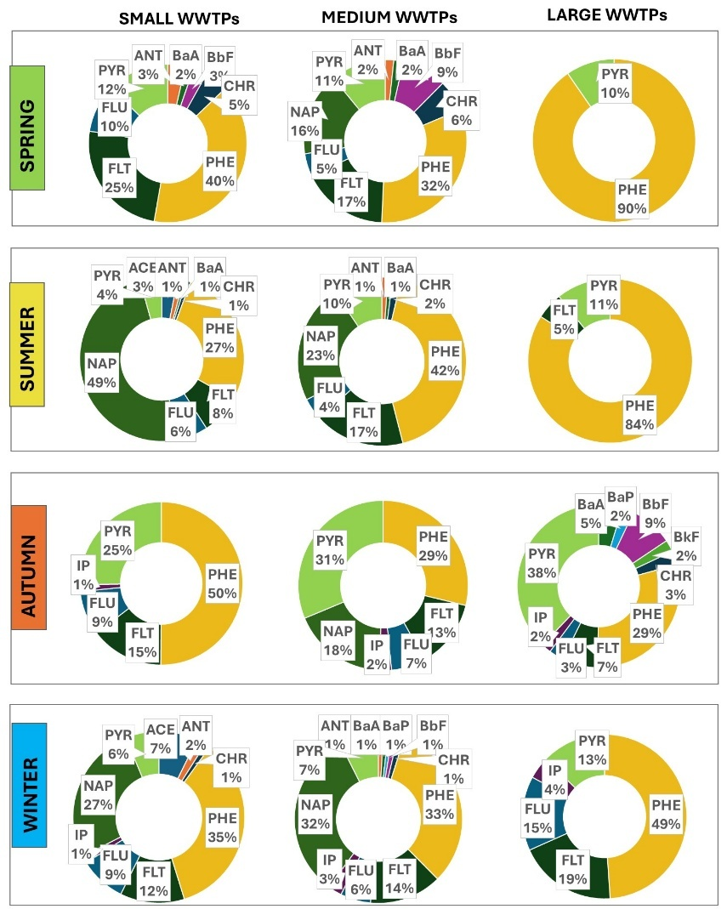
Fig.6 Share of individual PAHs in wastewater from the studied WWTP groups with regard to season (acenaphthene (ACE), anthracene (ANT), benzo(a)anthracene (BaA), benzo(a)pyrene (BaP), benzo(b)fluoranthene (BbF), benzo(k)fluoranthene (BkF), chrysene (CHR), phenanthrene (PHE), fluoranthene (FLT), fluorene (FLU), indeno(1,2,3-cd)pyrene (IP), naphthalene (NAP), pyrene (PYR))

3.2 Industrial wastewater quality in the catchment
Although clustering of the samples separated them into three groups (ellipses A, B1, B2), no clear seasonal pattern was observed in the studied samples. The FLU, PYR, PHE, and PAH SUM vectors are directed toward the samples marked with ellipse B1—one industrial wastewater sample from winter, two from autumn, and one from summer. The vectors of the remaining PAHs (IP, ANT, FLT) are directed toward one industrial wastewater sample collected in spring—ellipse A (Fig. 7). The remaining samples are grouped with ellipse B2 in the upper left and lower left quadrants opposite the PAH vectors. Nevertheless, it is worth noting that the sample size was small, i.e. only four industrial plants, which may significantly affect the distribution and interpretation of the results obtained. The dendrogram used to determine the ellipses is provided in the Supplementary Information (Fig. SI2).
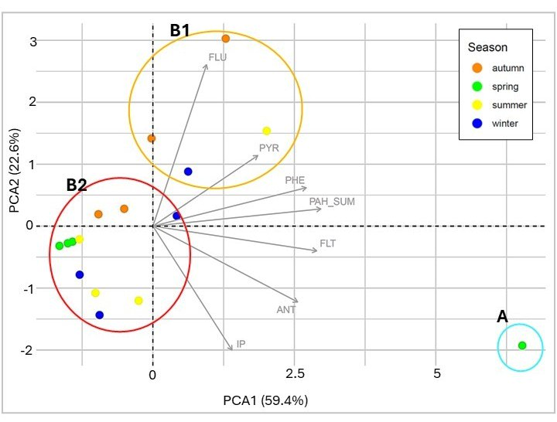
Fig.7 PCA score plot for industrial wastewater samples, coloured by season. PCA cluster membership marked by ellipses. The corresponding hierarchical dendrogram is provided in the Supplementary Information (Fig. SI2); green dot – spring, yellow dot – summer, orange dot – autumn, blue dot – winter.
For treated wastewater from industrial plants, Spearman’s analysis indicated a number of significant positive correlations: between oxygen concentration and PYR, TSS and ANT, BaP, BbF, BkF, CHR, PHE, FLT and PAH SUM; BOD₅ and PHE, FLT and PAH SUM, Ca²⁺ ion level and IP, F⁻ ion level and PYR. The remaining statistically significant correlations were negative (Fig.8). Hence, the presence of PAHs appears to strongly correlate with suspended solids, which suggests that PAHs are largely associated with the solid fraction of wastewater and can be adsorbed on colloidal and suspended particles. However, negative correlations were noted between PAHs and selected ions (e.g. Na²⁺, K⁺, Mg²⁺, SO₄²⁻, Cl⁻), conductivity (SPC) and salinity; this may indicate that in industrial wastewater, salinity or ionic composition limits their solubility or affects their fractionation. As such, some of the PAHs appear to pass into forms associated with sediment or, for example, emulsify in the presence of surfactants. Moreover, the lack of clear correlations with temperature and pH suggests that physical parameters play a lesser role in determining the presence of PAHs in industrial wastewater, compared to chemical composition and type of industrial activity.
A number of compounds, including PHE, FLT and FLU demonstrate common correlation patterns between samples, indicating common industrial sources and similar environmental properties. They may derive from inter alia fuel combustion processes, pyrolysis, tar processing and technical oils.
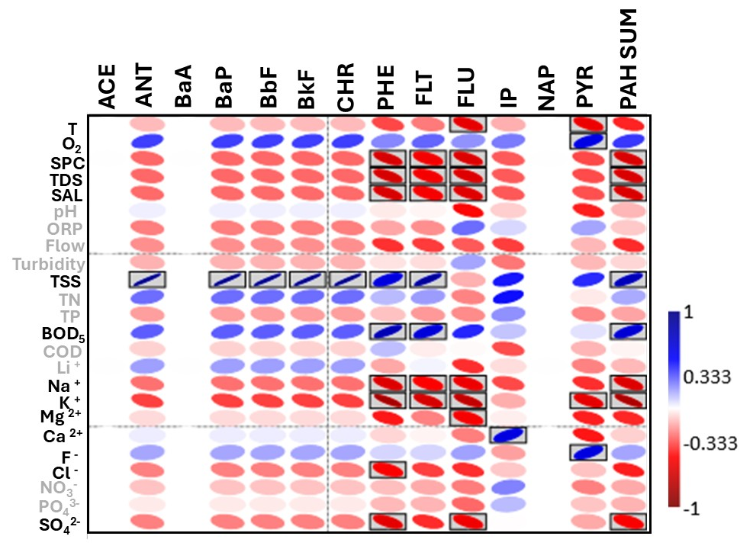
Fig.8 Spearman’s correlation matrix between PAH concentrations in treated sewage from industrial wastewater treatment plants and physico-chemical parameters. Statistically-significant values (p>0.05) are indicated by frames: acenaphthene (ACE), anthracene (ANT), benzo(a)anthracene (BaA), benzo(a)pyrene (BaP), benzo(b)fluoranthene (BbF), benzo(k)fluoranthene (BkF), chrysene (CHR), phenanthrene (PHE), fluoranthene (FLT), fluorene (FLU), indeno(1,2,3-cd)pyrene (IP), naphthalene (NAP), pyrene (PYR). Physico-chemical factors for which significant correlations were observed are highlighted in black.
The analysis of treated wastewater from industrial WWTPs found the highest total PAH loads entered the Pilica with from fruit and vegetable plants (I2 and I3). The highest loads from plant I2 were generated in autumn (31.84 mg/day) and winter (33.57 mg/day), while the highest from plant I3 were generated in autumn: 35.85 mg/day. It was the highest load among all analysed samples (Fig.9A). In almost all seasons, the lowest loads were detected in sewage from the dairy industry, with the exception of winter, during which the lowest total sum of the PAH load (SUM PAH) was identified in wastewater from the furniture industry (Fig.9A).
Among the identified PAH compounds, the most common was phenanthrene (PHE). In addition, PYR and IP were also frequently identified. The greatest variation in PAH content among the tested samples was noted in wastewater from the furniture (I4) and fruit and vegetable industries (I2), regardless of load size. In the dairy industry plant (I1), only PHE was identified, with FLT, IP and PYR present in individual samples. Samples from plant I3 also contained PHE was observed, as well as small loads of IP and PYR. ACE, BaA and NAP were not identified in any of the samples, and ANT, BaP, BbF, BkF and CHR were present only in the furniture industry wastewater collected in spring (Fig.9B).
In summary, it can be seen that PAH emission demonstrates seasonal variation, peaking in the autumn-winter period, which may be related to seasonal industrial processes (e.g. combustion, heat production, changes in raw material consumption). Among the tested industrial waste samples, particularly high PAH emissions were noted at I2 and I3, and these areas should be covered by priority monitoring and source analysis. The PAH profile was also found to vary between locations, with more PAHs being observed at points with a higher load; as such, this is an important consideration when assessing environmental risk.
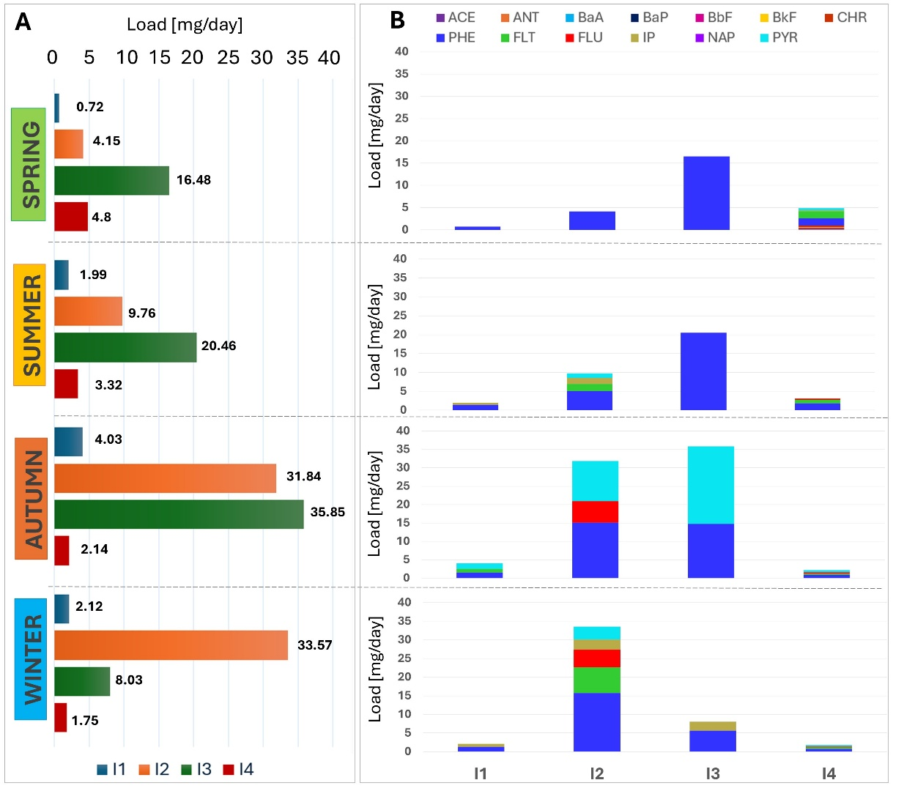
Fig.9 Seasonal loads [mg/day]of the sum of PAHs A. Identified in samples of industrial wastewater samples and B. Diversity of PAHs present in samples; I1 – dairy industry, I2 and I3 – fruit and vegetable industry, I4 – furniture industry. (acenaphthene (ACE), anthracene (ANT), benzo(a)anthracene (BaA), benzo(a)pyrene (BaP), benzo(b)fluoranthene (BbF), benzo(k)fluoranthene (BkF), chrysene (CHR), phenanthrene (PHE), fluoranthene (FLT), fluorene (FLU), indeno(1,2,3-cd)pyrene (IP), naphthalene (NAP), pyrene (PYR))
The analysis of PAH sources revealed clear differences between the studied industrial plants and across seasons (Fig.10). The PAH diagnostic ratios indicated that the predominant sources of PAHs in the dairy industry during spring, summer and winter were pyrogenic sources such as diesel emissions and wood or coal combustion. In autumn, petrogenic sources were also identified in addition to the pyrogenic origins.
Both fruit and vegetable processing plants exhibited greater variability with regard to potential emission type. In plant I2, petrogenic sources dominated in autumn, while combustion-related (pyrogenic) processes were prevalent in the other seasons. In contrast, in plant I3, pyrogenic sources dominated throughout the entire year, regardless of the season. In contrast, in the furniture plant, most of the total PAH emissions derived from petrogenic sources, likely associated with the use of oils, solvents, and other petroleum-derived products in wood processing, varnishing, and gluing operations. The lower contribution of pyrogenic sources in most seasons suggests limited use of solid fuels or effective ventilation and filtration systems in the plant.
In the furniture industry, the contribution of pyrogenic sources to PAH pollution increased in autumn. This may be related to seasonal heating of production halls, the use of local heat sources fueled by wood or coal, and increased operation of diesel-powered machinery.
Fruit and vegetable processing plants (I2 and I3) exhibited greater variability in potential PAH sources. In plant I2, petrogenic sources dominated in autumn, likely due to increased use of liquid fuels and lubricants in transportation or heating, while combustion-related (pyrogenic) processes prevailed in the other seasons. In plant I3, pyrogenic processes predominated throughout the year, highlighting the dominant role played by emissions from boilers and internal combustion machinery.
Overall, the differences between the industries can be explained by the nature of the materials and technologies used: While petrogenic emissions related to petroleum-derived products predominate in the furniture industry, pyrogenic sources associated with combustion during heating, drying, or cooking play a more significant role in the food processing industry.

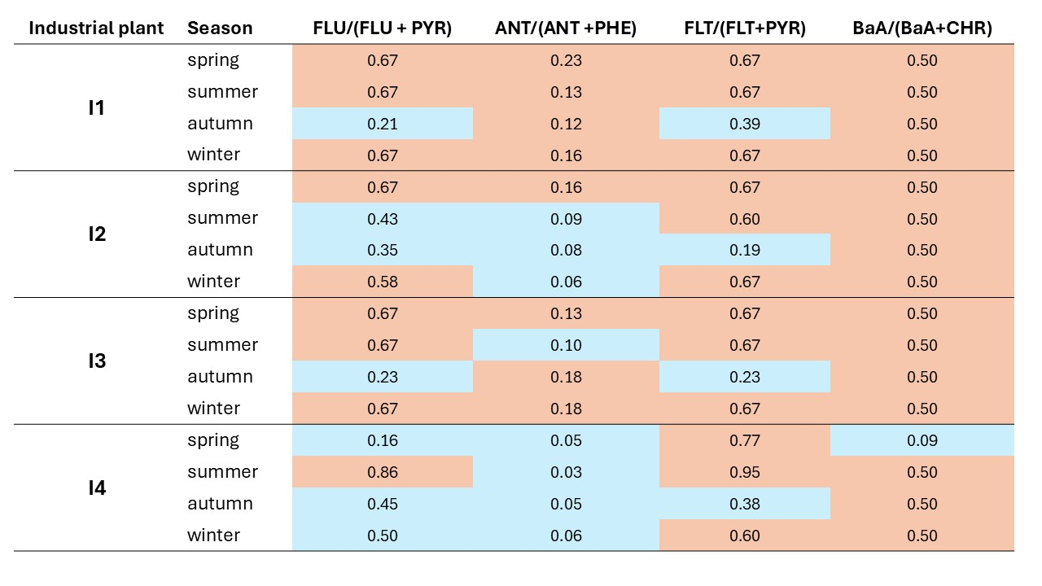
Fig.10 PAH ratios for individual treated industrial wastewater samples located in the Pilica River catchment, indicating potential sources of PAHs. Blue FLU/(FLU+PYR) < 0.5 – petrol emissions, orange FLU/(FLU/PYR) > 0.5 - diesel emissions; blue ANT/(ANT+PHE) < 0.1 - petrogenic sources, orange ANT/(ANT+PHE) >0.1 - pyrogenic sources; blue FLT/(FLT+PYR) < 0.4 – petrogenic sources, orange FLT/(FLT+PYR) > 0.5 - Grass, wood, coal combustion; blue BaA/(BaA+CHR) <0.2 – petrogenic sources, orange BaA/(BaA+CHR) >0.35 combustion processes (classification based on Tobiszewski & Namieśnik, 2012).
  - Riverine water quality along the river continuum
In the PCA analysis performed on river water samples, the PCA1 axis accounted for 67.2% of the variance, and the PCA2 axis for 16.4%. Clustering based on the dendrogram (contained in the Supplementary Information - Fig. SI3) divided the samples into three groups - A, B1, and B2. The lower left and right quadrants contain samples collected in winter (ellipse B1), representing the middle and lower parts of the river (Fig. 11 A, B). The vector defining IP is directed towards them. Vectors defining the concentrations of NAP, PYR, FLU, PHE, FLT, and PAH SUM are directed towards ellipse A, grouping autumn samples collected in the middle part of the river (Fig. 11 A, B). The remaining samples were grouped by ellipse B2 and are located in the left half of the graph, indicating weak or no affinity for PAHs. The dendrogram used to determine the ellipses is provided in the Supplementary Materials (Fig. SI 3).
Unlike the sewage treatment plant samples, this analysis indicates a possible relationship between seasonality and the occurrence of the analyzed PAHs in the river water samples. The obtained results suggest that the nature of the river basin significantly influences the water quality of the Pilica River. The presence of numerous urban agglomerations, industrial plants, and sewage treatment plants significantly influences the pollution generated in the river basin.
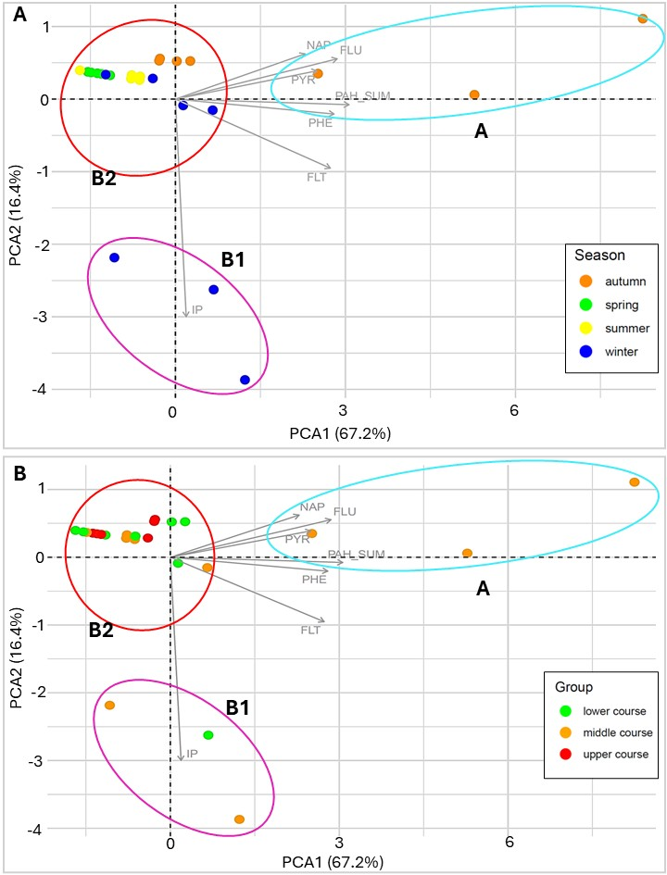
Fig.11 PCA score plot for river water samples, coloured by season (A) and WWTPs group (B). PCA cluster membership marked by ellipses. The corresponding hierarchical dendrogram is provided in the Supplementary Information (Fig.SI3); A: green dot – spring, yellow dot – summer, orange dot –autumn, blue dot – winter; B: red dot –upper course of the river (R1, R2), orange dot –middle course of the river (R3, R4, R5), green dot –lower course of the river (R6, R7 points).
Spearman’s correlation analysis found the levels of PHE, FLT, FLU, IP, NAP, PYR and PAH SUM to be associated with the following physico-chemical factors: oxygen content, SPC, TDS, SAL, ORP, flows, TN concentrations and NO₃⁻ ion level. In addition, PHE, FLT, PYR and PAH SUM were significantly negatively correlated with temperature, PYR with pH and Ca²⁺ ions, and PHE with Li⁺ ion content (Fig.12).
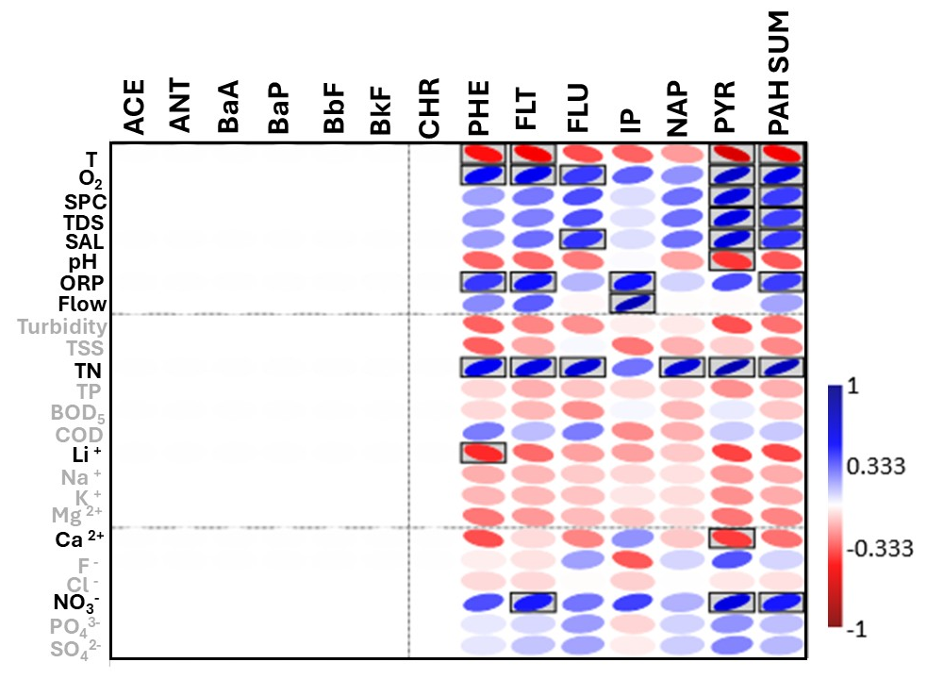
Fig.12 Spearman’s correlation matrix between PAH concentrations in riverine water and physico-chemical parameters measured for the collected samples. Statistically-significant values (p>0.05) are marked in frames: acenaphthene (ACE), anthracene (ANT), benzo(a)anthracene (BaA), benzo(a)pyrene (BaP), benzo(b)fluoranthene (BbF), benzo(k)fluoranthene (BkF), chrysene (CHR), phenanthrene (PHE), fluoranthene (FLT), fluorene (FLU), indeno(1,2,3-cd)pyrene (IP), naphthalene (NAP), pyrene (PYR). Physico-chemical factors for which significant correlations were observed are highlighted in black.
In river water samples, the highest sum of PAH loads were observed in autumn (maximum load in R4 - 248.81 g/day) and winter (maximum load in R6 - 254.40 g/day) (Fig.13). In addition, in all seasons, loads increased from R1 to R6. In autumn and winter, high loads are observed in point R4, while the highest PAH load of all tested samples was observed in winter in point R6, located closest to the mouth of the Pilica River to the Vistula. Due to the lack of data on flows in point R7, this point was not included in the analyses.
During spring, the only PAH detected in the analysed samples was phenanthrene, which constituted 100% of the PAH SUM index at all analysed points. In summer, this compound was the only one detected in samples R1, R2, R4 and R5; however, PYR was also detected at R3 and R6, constituting 20% ​​and 17.66% of PAH SUM, respectively. In the colder period of the year, PAH SUM consisted of PHE, FLT, FLU, NAP and PYR in autumn, and PHE, FLT, IP and PYR in winter; in both seasons, phenanthrene also represented a significant component of PAH SUM.
It should be noted that pollutant loads are closely related to the river flows measured at the water gauge points on the Pilica River, with the mean flow rates being 21.53 m³/s in spring, 13.0 m³/s in summer, 22.32 m³/s in autumn and 57.23 m³/s in winter. Moreover, due to the increasing number of river tributaries, the flows increase along the river continuum, which also affects the final results obtained at the analyzed points. The degree of pollution at the given points may be related to the proximity of the analyzed point sources i.e. the WWTPs.
To sum up, PAH load is seasonal. The analyzed river points are located near urbanized areas, and the highest loads are observed in the autumn-winter period, which may be related to the deposition of PAHs from combustion processes or heat production.
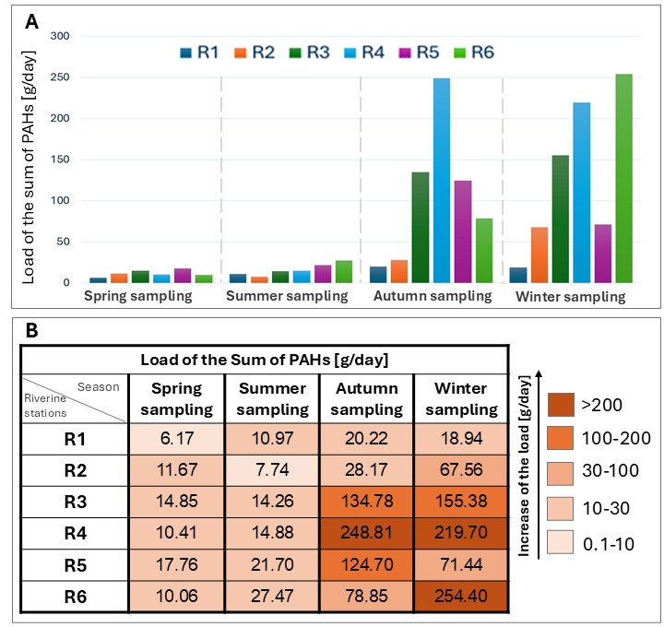
Fig.13 A. Dynamics of total PAH load [g/day] along the continuum of the Pilica River during sampling according to specific season; B. Total PAH loads (PAH SUM) [g/day] in the river water along the Pilica River continuum identified during the years 2022-2023 (samples collected on days classified as spring, summer, autumn, and winter).
- Discussion
This article attempts to analyze the impact of pollution from point sources on water quality in the Pilica Piver; however, unlike previous studies, the analysis encompasses pollutants entering the river from the entire area of ​​its catchment. This approach offers a holistic picture of the problem related to the pollution of municipal and industrial sewage with PAHs, a group of compounds considered harmful to ecosystems. Despite this, the assessment is beset by some ambiguity due to the temporary nature of the samples and the variability in the river flow. In addition, a large amount of data was found to be below the quantification threshold, with these thresholds being strongly influenced by the complexity of the tested matrices, further complicating any accurate assessment of the scale of environmental pollution.
  - PAHs in municipal wastewater
The analyses indicate that despite being subjected to treatment processes, wastewater remains a significant source of PAHs in the environment (Fig. 5). The PCA analysis found the smallest treatment plants to have the highest affinity for PAHs such as ACE, NAP, FLU, PHE, FLT, ANT and PYR (Fig. 3B). Nevertheless, the highest estimated daily loads of PAHs generated from individual treatment plants came from large WWTPs (Table 2), which was closely related to the size of daily flows recorded in these treatment plants. In addition, the wastewater supplying large WWTPs typically includes pollutants from large areas with high population density, together with those carried through the combined sewer system (Zhang et al., 2019). The anthropogenic sources of PAHs include the combustion of organic matter and industry, car emissions, smoke from wood-burning stoves, aircraft exhaust, cigarette smoke and grilling, oil spills, tar and creosote waste. In addition, PAHs can be released from the atmosphere with dry or wet deposition, from where they settle on the ground or surface waters, or are washed away with rain into the sewage system. As such, urban environments tend to be characterized by higher concentrations of PAHs than rural areas (Abdel-Shafy & Mansour, 2016). This is confirmed in our present findings, which indicate higher concentrations in WWTPs located closer to larger urban agglomerations (Fig.5).
Studies have frequently confirmed the presence of PAHs such as phenanthrene (PHE), naphthalene (NAP), acenaphthene (ACE) and fluorene (FLU) in municipal wastewater. Their elimination ranges from 40 to 60% in pretreatment processes, and from 10 to 90% during biological treatments (Gaurav et al., 2021). One analysis found PAHs to be eliminated from wastewater at with an efficiency of about 80%; although total PAH content was found to be in the range of 43.5±42.5 ng/L in the treated wastewater (Ozaki et al., 2015). In the present analysis, the mean of the sum of PAH concentration for all analyzed samples is 90 ng/L.
Our present findings indicate the most frequently-identified PAHs in the samples to be phenanthrene (PHE) and naphthalene (NAP), which were also detected in the highest concentrations. Similar results were also obtained by Ozaki et al. (2015) who found phenanthrene to have the highest concentrations among 16 analyzed PAHs in both the influent and effluent of a studied WWTP. A study of PAHs in wastewater from the Konya, Eregli and Zincirlikuyu WWTPs (Nas et al., 2020) found NAP to be present at the highest concentrations (103-370 ng/L after treatment), with the second most common being ANT, followed by BbF, BkF, BaP, IP, FLU, and also BghiP, which was not detected in our samples. The total PAH content in treated wastewater was found to be 338 ng/L in the Konya WWTPs, 603 ng/L in the Eregli WWTPs and 334 ng/L in the Zincirlikuyu WWTPs (Nas et al., 2020).
Although the PCA analysis did not indicate any significant effect of seasonality on the observed PAH concentrations, high PAHs loads were noted in autumn and winter. This is identical to the results obtained by Włodarczyk-Makuła (2005), who report total PAH loads of 70.3 g/day in winter and 46 g/day in summer in sewage from WWTP with PE > 100,000 (Włodarczyk-Makuła, 2005). In the winter months, increased PAH emission can be observed, which could be associated with a greater amount of vehicle exhaust fumes and increased coal combustion during space heating (Li et al., 2006). This may also explain our present findings. Moreover, the occurrence of these compounds in the environment, and their concentrations, may be directly influenced by various factors such as microbiological activity, which is reduced in colder months (Bourhane et al., 2022), as well as the characteristics of the compounds themselves. Grmasha (2024) reports the presence of low molecular-weight polycyclic aromatic hydrocarbons (LMWPAHs) in water during the cold seasons, viz. winter, autumn and spring, while high molecular-weight PAHs (HMWPAHs) were present mainly in summer. This is due to the low solubility and dissolution rate of HMWPAHs, making them more resistant to degradation, whereas LMWPAHs are more soluble and more easily degraded in the warm season (Grmasha et al., 2024). The solubility of PAHs is also influenced by environmental temperature, with an increase in solubility resulting in an exponential increase in solubility, reaching a factor of 10 to 20 in the temperature range of 10–70°C (Koproch et al., 2019). An important role is also played by the concentration of dissolved organic matter (DOC), especially for PAHs containing five or more aromatic rings, whose concentrations matched the seasonal variability as DOC, i.e. peaking in late summer; in contrast, the levels of PAHs with two or three rings peaked in winter (Moeckel et al., 2014).
Also in the present study, many significant positive correlations were noted between PAH content and total suspended solids in the treated wastewater from WWTPs (Fig. 4). In the case of suspended solids, due to their low solubility in water and high hydrophobicity, PAHs quickly bind to particles suspended in solution and thus accumulate in sediments. As such, sediments are considered a significant repository of PAHs in the aquatic environment (Feng et al., 2008). Most significantly, any increase in the total suspended solids concentration brings with it higher concentrations of biogenic compounds, i.e. nitrogen and phosphorus (Paudel et al., 2019). Our analyses reveal strong positive correlations between biogenic compounds and PAHs. This indicates the complexity of the matrices and the existence of dependencies between all analyzed physicochemical factors defining the nature of the samples.
In addition, strong positive correlations were identified between PAH levels and BOD₅ (Fig. 4). This is confirmed by literature data. Ofman (2021) found an increase in BOD load to be accompanied by a decrease in the removal efficiency of individual PAHs, and thus an increase in their concentration in the solution. Importantly, in the cited studies, BOD appears to be an indicator of the amount of biodegradable organic compounds present in the activated sludge; this confirms that other compounds can also affect the content of PAHs in water matrices (Ofman et al., 2021).
  - PAHs in industrial wastewater
    - Dairy industry
The highest total PAH load in treated sewage from the dairy plant was recorded for autumn (4.03 mg/day), with the remaining loads ranging from 0.72-2.12 mg/day. The PAH composition did not vary considerably between samples, with phenanthrene, fluoranthene, indeno(1,2,3-cd)pyrene and pyrene being present in the treated wastewater (Fig.9). PAHs can enter the dairy industry through contamination of milk. It is believed that the PAHs enter ruminant milk through consumption of contaminated feed, grass and soil near industrialized areas, as well as contaminated soil. Due to their lipophilic nature, PAHs accumulate not only in the food chain but also in products with higher fat content. PAHs are commonly detected in dairy products such as milk (including PHE, NAP), infant formula (including PHE, NAP), cheese (including PHE, ACE, BbF) and yogurt (including BbF) (Shoaei et al., 2023); indeed, milk and dairy products are considered as carriers of PAHs (Amirdivani et al., 2019).
    - Fruit and vegetable industry
Fruit and vegetable processing plants generated the highest loads of total PAHs, i.e. 31.84 mg/day in autumn and 33.57 mg/day in winter from plant I2, and 35.85 mg/day in winter from plant I3. These samples contained PAHs such as phenanthrene, fluoranthene, fluorene, indeno(1,2,3-cd)pyrene, anthracene and pyrene (Fig.7). PAHs are believed to enter fruit and vegetable products through raw materials, with contamination occurring during growth, transport to the industrial plant or storage. In such cases, transfer can occur following deposition of contaminated solid particles landing on the surface of the plant or its fruit, whose hydrophobic surfaces can directly adsorb PAHs (Paris et al., 2018). PAHs can also enter fruits and vegetables from contaminated soil (Samsøe-Petersen et al., 2002), with a number of PAHs, such as acenaphthene, fluoranthene and phenanthrene, being used in pesticides and agrochemicals (Abdel-Shafy & Mansour, 2016). The pollutants are then released from the raw materials or washed away during food processing, and these then entering the wastewater from industrial plants (Paris et al., 2018).
    - Furniture industry
The total PAH wastewater loads generated from the furniture industry plant ranged from 1.75 to 4.8 mg/day depending on the season. Although the detected loads were not the highest among the analyzed plants, they were characterized by a wide diversity of PAHs: anthracene, benzo(a)pyrene, benzo(b)fluoranthene, benzo(k)fluoranthene, chrysene, phenanthrene, fluoranthene, fluorene, indeno(1,2,3-cd)pyrene and pyrene.
PAHs are incorporated in a range of products used in the furniture industry, including pigments and dyes (acenaphthene, anthracene, fluoranthene, fluorene, pyrene), wood preservative diluents (anthracene), and resins (phenanthrene) (Abdel-Shafy & Mansour, 2016). Hence, the PAHs observed in wastewater from the furniture industry could have originated from various stages of the technological processes related to the processing, gluing, and finishing of wooden surfaces. These compounds may enter wastewater from cleaning tools, paint booths and spray equipment, and from tanks used with varnishes, paints, stains or organic solvents containing aromatic hydrocarbon derivatives. Additionally, in facilities using thermal processes such as drying, bending, or wood residue combustion, PAHs can be generated as a result of incomplete combustion of organic matter. These pollutants can settle in dust and sediments, and may subsequently be washed into the wastewater system.
These are the reasons why these compounds are commonly detected in the gas and molecular phase in regions rich in furniture workshops, with mean concentrations as high as 697.82 ng/m³ (gas phase) and 413.52 ng/m³ (particulate phase) (Caliskan et al., 2020). In furniture factories, PAH concentrations in wood dust generated during processing can range from 0.24 to 7.95 ppm, with workers receiving exposure levels of 37.5–119.8 ng/m³ in the plant (Bruschweiler et al., 2012).
  - PAHs in river water
Almost all analyzed river water samples were found to contain PAHs. Although PAHs have low solubility In aqueous solutions, they are often identified in rivers, which could be due to them being flushed from the environment by rain. Moreover, less soluble PAHs have a high affinity for particles suspended in water, and thus readily accumulate in sediments. Following this, their slow re-release from sediments results in the re-emission of PAHs into water matrices (Torretta, 2012).
The flow rate plays an important part in the re-emission process. During sampling, the mean flows were 21.53 m³/s in spring, 13.0 m³/s in summer, 22.32 m³/s in autumn and 57.23 m³/s in winter. PCA analysis of seasonal river water samples (Fig.11A) showed a relationship between the PAH levels and colder seasons. Indeed, the highest daily total PAH values were noted in autumn (20.22 g/day – 248.81 g/day) and winter (18.94 – 254.40 g/day); while PAHs could also be observed in spring and summer, the loads were much smaller: max. load of 17.76 g/day for spring R5 and max. load of 27.47 g/day for summer R6. It can be seen that flow rate affects not only the washing out of PAHs from sediments, but also the size of the loads resulting from PAH concentration and flow. The seasonal nature of the analyzed samples is also related to the occurrence of PAHs in specific parts of the river. For example, samples collected in winter and autumn represented those from the lower and middle sections of the river (Fig. 11B), which may be related to the development of the catchment area by large urban agglomerations and highly developed industry, as well as the transport, concentration and accumulation of pollutants flowing from the upper part of the river. For example, in winter, air in upper Silesia, south-west Poland, has been found to contain levels of molecular-phase fluoranthene about 30 times higher than in summer, which has been attributed to the use of coal for heating houses (Bodzek et al., 1993).
Spearman’s correlation analysis found the presence of PAHs in the analyzed river water samples (PHE, FLT, FLU, IP, NAP, PYR and PAH SUM) to have a positive significant influence on inter alia oxygen content, SPC, TDS, SAL, ORP, flows, and NO₃⁻ ion content. The highest number of positive correlations was shown for TN concentration. The use of nitrogen in soil fertilization can affect changes in the properties of the soil microenvironment, and can alter the chemical structure and pH of soil and its dissolved organic matter content, which also influence the of PAH adsorption and accumulation (Hui et al., 2022a). Indeed, soils fertilized with sewage have been found to demonstrate higher PAH concentrations, which also increased with the presence of nitrogen in the soil; these concentrations increased further with long-term N addition, ranging from 7598 μg/kg to 10414 μg/kg (Hui et al., 2022b). Both PAHs and TN can be washed out of soils during heavy rainfall, thus reaching aquatic ecosystems. However, the effect of temperature and salinity on PAH concentrations can be explained mainly by changes in the solubility of pollutants in aqueous solutions; for example, decreasing water temperature and increasing salinity together increase the fraction of pollutants adsorbed to particles by 40% - 64% (Tremblay et al., 2005).
The occurrence of PAHs in rivers is a common phenomenon. In the Tianjin River in China, the concentration of total PAHs ranged from 0.787 to 1943 µg/g dry weight of sediment, from 45.81 to 1272 ng/L in water and from 0.938 to 64.2 µg/g dry weight of suspended particle matter (Shi et al., 2005). In the Kor River in Iran, the mean concentration of total PAHs ranged from 51.42 ng/L to 291.4 ng/L; also, similar to the present study, the highest mean PAH concentrations were detected in autumn (11.88 ng/L) (Kafilzadeh et al., 2011). In Paranagua Bay, Southern Brazil, the concentrations of total PAHs ranged from 51.20 to 162.37 µg/L (Froehner et al., 2018). In the Danube River (Hungary), PAHs were identified throughout the year, with the levels ranging from 283.1 to 541.9 ng/L in winter, 198.6–404.3 ng/L in spring, 160.0–324.6 ng/L in summer and 228.2–378.1 ng/L in autumn (Grmasha, et al., 2024). Analyses carried out in the urban section of the Tiber River (Italy) found the concentrations of PAHs in water to range from 23.9 to 72.0 ng/L, with their main sources being pyrolytic processes and traffic emissions (Patrolecco, et al., 2010). In addition, in the Kurose River in the suburban area of ​​Hiroshima Prefecture (Japan), the concentrations of dissolved PAHs ranged from 12 to 58 ng/L and particulate PAHs from 8 to 105 ng/L during rainfall, compared to 10-58 ng/L (dissolved) and 4–418 ng/L (particulate) during rainless periods (Iwasaki et al., 2009).
PAHs were also detected in the Amazon River, with the total concentrations of 16 priority PAHs reaching 134 ng/L in the river itself and 163 ng/L near densely-populated areas. Most samples contained primarily high-molecular-weight compounds, suggesting pyrolytic sources. However, petrogenic contamination also occurred near cities, which also influenced the occurrence of PAHs in surface waters (Rizzi et al., 2023).
In the Haihe River system, PAHs (0.16–1.20 μg/l in the aqueous phase; 1.56–79.38 μg/g in the particulate phase) were accompanied by methyl-PAHs (MPAHs) (0.02–0.40 μg/l in the dissolved phase; 0.32–16.54 μg/g in the particulate phase) and oxygenated-PAHs (OPAHs) (0.06–0.19 μg/l; 0.41–17.98 μg/g). Their primary sources were found to be wastewater treatment plants (WWTPs), being responsible for the supply of 62.3% to 87.6% of MPAHs, 68.5–89.4% of PAHs, and 80.3–93.2% of OPAHs to the rivers, depending on the season (Qiao et al., 2014).
An analysis of the surface waters of the Ganges River along a 2,500-kilometer stretch from the Himalayas to the lower reaches revealed total PAH concentrations ranging from 0.05 to 65.9 ng/L. In the middle and lower reaches, fossil fuel combustion was identified as the main source of PAHs, whereas in the Himalayan region, forest fires and biomass burning dominated during the dry season. Seasonal variations in water concentrations were most pronounced in the upper reaches, likely due to contaminant release from melting glaciers. The lower reaches demonstrated less seasonality, and anthropogenic activities remained the prevailing source (Sharma, et al., 2018).
In turn, an analysis of water samples collected from the Ovia River in southern Nigeria found the mean total PAH concentrations in surface waters to range from 2.33 to 25.83 µg/L. In all analyzed matrices, 2- and 3-ring compounds predominated, with the highest PAH concentrations recorded at the Ekenwan sampling site located in the lower course of the river (Tongo et al., 2016).
In Poland, PAH pollution has also been recorded in the Wisłok River, where they were identified in bottom sediments, with total concentrations ranging from 0.218 to 8.437 mg/kg of dry sediment mass and the highest PAH concentrations being recorded for fluoranthene, benzo(a)anthracene and pyrene (Książek, et al., 2016). Also in Poland, PAHs were recorded in the sediments of the Odra River and its tributaries with concentrations ranging from 150 to 19000 ng/g of dry sediment mass (Kannan et al., 2003).
- Legal regulations regarding PAHs
Due to their mutagenic, teratogenic and carcinogenic effects on living organisms, PAHs are subject to regulations concerning the health and well-being of aquatic ecosystems (Smol et al., 2017). Out of 16 PAHs, nine are included in the list of priority substances issued by the European Commission: benzo(a)pyrene, benzo(b)fluoranthene, benzo(g,h,i)perylene, benzo(k)fluoranthene, indeno(1,2,3-cd), anthracene, pyrene, fluoranthene and naphthalene. In addition, the maximum allowable levels of benzo(a)pyrene, and the sum of benzo(a)pyrene, benz(a)anthracene, benzo(b)fluoranthene and chrysene, are included in the regulations on food, in accordance with Commission Regulation (EC) No 835/2011 (HELCOM, 2018).
According to Directive 2013/39/EU of the European Parliament and of the Council, the maximum allowable concentrations (MAC) of PAHs in surface waters should not exceed the following: for anthracene 0.1 µg/L (all types of surface waters), for benzo(a)pyrene 0.27 µg/L (inland surface waters) and 0.027 µg/L (other surface waters), for benzo(b)fluoranthene and benzo(k)fluoranthene 0.017 µg/L (all types of surface waters), benzo(g,h,i)perylene 0.0082 µg/L (inland surface waters) and 0.00082 µg/L (other surface waters), for fluoranthene 0.12 µg/L (all types of surface waters), for naphthalene 130 µg/L (all types of surface water). In the case of indeno(1,2,3-cd)pyrene, no limits are specified in the document (European Union, 2013). These values ​​are also taken into account when assessing the ecological status and chemical status of surface water bodies (Ministry of Infrastructure, 2021).
None of these parameters were exceeded in the present study for river water samples. Interestingly, however, the highest recorded concentrations for the tested compounds were observed for naphthalene (0.039 µg/L) and phenanthrene (0.034 µg/L), which are not included in the regulations.
Currently, no document directly specifies the permissible concentrations of PAHs in municipal and industrial wastewater. The amounts of PAHs entering the environment from point sources of pollution can therefore only be regulated indirectly by observing general restrictions related to maintaining the good quality of aquatic ecosystems. For example, the Water Framework Directive (2000) introduces the concept of priority substances, which includes PAHs; in addition, while it does not include a regime for PAH concentrations in wastewater, the WFD imposes an obligation to control sources of pollution, including point sources such as industrial and municipal wastewater, and also requires Member States to take measures to prevent emissions of these substances into surface waters (European Union, 2000). Standards regarding wastewater quality are also specified in Council Directive 91/271/EEC of 21 May 1991 (replaced by Directive (EU) 2024/3019 from 2027), which does not refer directly to PAHs or list them. However, by establishing general requirements for wastewater treatment and monitoring the quality of receiving waters, it indirectly affects the presence of PAHs in the aquatic environment (European Union, 1991, European Union, 2024). In addition, PAHs are specified in numerous international documents as being compounds with a special need for monitoring and control. Such documents include inter alia the Drinking Water Criteria Document for Polycyclic Aromatic Hydrocarbons (PAH) (United States EPA, 1991) or the Clean Water Act (United States Congress, 1972).
- Biological methods for eliminating PAHs from the environment
The ensure the protection of aquatic ecosystems, there is a need to identify effective technologies for removing PAHs from the environment. Conventional methods for the elimination of PAHs from water solutions and wastewater can be divided into four main groups: chemical methods (including coagulation, oxidation), physical methods (including photodegradation, sorption, membrane techniques, reverse osmosis), biological processes (including bioremediation and phytoremediation) and their combinations (Smol & Włodarczyk-Makuła, 2017). However, these processes are limited by high investment and maintenance costs, and complicated operating procedures. In addition, some of these treatment processes release secondary by-products that are carcinogenic and mutagenic compounds (Lamichhane et al., 2016).
The increasing costs and limited efficiency of traditional physicochemical methods of environmental remediation have aroused greater interest in the use of biological methods (Bisht et al., 2015) such as ecohydrological biotechnologies and Nature-Based Solutions (NBS). These solutions are currently the preferred approach to environmental remediation, and are therefore included in inter alia European Commission programs such as Horizon Europe and the IX phase of the UNESCO Hydrological Program (Matuszewska et al., 2025).
It is worth noting that biological processes also have their drawbacks, especially in the case of industrial wastewater treatment. Their effectiveness can be limited by the fact that substances such as PAHs generated by industry can be highly toxic to the remediation organisms or resistant to biological treatment (Smol & Włodarczyk-Makuła, 2017). Nevertheless, due to the fact that biological processes are eco-friendly, low-cost solutions in the elimination of PAHs from the environment, they are nevertheless a rapidly-developing topic.
  - Bioremediation
Bioremediation processes include biodegradation and biotransformation, which facilitate the transformation or decomposition of toxic substances into environmentally-safe forms, i.e. compounds with a simpler structure, or CO₂, H₂O and biomass. The efficiency of biodegradation depends on the type of compound, the presence of appropriate microorganisms and the physicochemical conditions of the environment. Higher temperatures can increase the bioavailability and reaction rate, but can also reduce the solubility of oxygen, which can limit the activity of aerobic microorganisms and slow down the decomposition process (Gupte et al., 2016).
Biodegradation efficiency is also influenced by the content of sediment in the river. A study of the Yellow River found that increased sediment content increased the biodegradation of the PAH chrysene, benzo(a)pyrene and benzo(g,h,i)perylene with phenanthrene as a substrate for co-metabolism. This was related to fact that higher amounts of sediment harbor larger populations of PAH-degrading bacteria and higher levels of PAHs. Desorption of PAHs from the solid phase increased their concentration in the water-sediment contact zone, favoring more intense interactions between microorganisms and pollutants (Xia et al., 2006).
The effective degradation of PAHs can be optimized by using bacterial consortia. For example, a consortium consisting of bacteria of the genera Sphingobium and Pseudomonas was able to remove 100% of a PAH mixture from a small-scale sewage system within five days, maintaining high degradation stability for 24 days. This consortium was shown to be able to effectively utilize phenanthrene or dibenzothiophene as a sole carbon source; in addition, when grown on a phenanthrene substrate, it could also degrade naphthalene, acenaphthene, fluorene, anthracene, fluoranthene, benzo(a)anthracene, dibenzofuran, carbazole, and indole (Zhang et al., 2021). Analyses of PAHs degradation based on a consortium of Pseudomonas aeruginosa and Alcaligenes faecalis bacteria obtained from oily sludge showed that the degradation efficiency differs depending on the environmental conditions. After eight days of incubation at 35°C and pH 7, the degradation rate of PAHs was 90% NAP, 80% PHE, and 70% PYR; in addition, degradation was inhibited by the addition of surfactants and by using the following minimum ion concentrations: Cu²⁺ 2.002 mM, Zn²⁺ 17.388 mM, and Pb²⁺ 9.435 mM (Zhang et al., 2022). The effectiveness of bacterial consortia in PAHs degradation is also confirmed by the studies of Xu (2022). The effectiveness of the mixture consisting of Comamonas testosteroni, Pseudomonas putida, Acinetobacter calcoaceticus, Rhodococcus sp., Pseudomonas stutzeri, Buttiauxella sp. and Vibrio sp. was 83% (Xu et al., 2022). Laboratory studies have shown that consortia composed of Staphylococcus warneri and Bacillus pumilus bacteria are also effective in eliminating PAHs (PHE, PYR, BaA), with the elimination efficiency reaching 90% after three days of experiments (Moscoso et al., 2012). A consortium consisting of Serratia marcescens L-11, Streptomyces rochei PAH-13 and Phanerochaete chrysosporium VV-18 was able to eliminate 60-70% of the given PAH mixture within seven days under controlled conditions. The same consortium in in situ conditions (soil) degraded 56-98% of the analyzed PAHs within seven days, and 83.5-100% degradation was obtained after 30 days (Sharma et al., 2016).
  - Phytoremediation
Phytoremediation should be understood as the degradation, extraction, or stabilization of pollutants in a given matrix by employing processes based on the use of plants, such as volatilization, rhizoremediation, phytotransformation, and phytostabilization. All of these mechanisms are supposed to favor the decomposition of organic pollutants into simpler molecules or their incorporation into plant structures (Gupte et al., 2016).
Plants of the species Phragmites australis and Typha domingensis can be effective in the phytoremediation of river sediments, where they accumulate PAHs in both the roots and the shoots (Alwan, 2016). One good example of the potential of phytoremediation can be seen in one study conducted in mesocosms, where Rhizophora mangle was used to eliminate PAHs from mangrove sediments contaminated with crude oil; the plant based system achieved 61% efficiency, while the plant-free control system achieved only 50% removal (Verâne et al., 2020). Similarly, Hydrilla verticillata, Myriophyllum verticillatum, Vallisneria spiralis and Potamogeton crispus were found to be effective in removing phenanthrene and pyrene from river sediments: the presence of plants increased the degradation of phenanthrene by 14.1–51.4% and pyrene by 7.4–44.1% compared to controls, i.e. sediment without plants. This efficiency can be attributed to the plant roots increasing the redox potential in the sediments, thus supporting the biodegradation processes, and underlining the inseparable synergism between microorganisms and plants (He & Chi, 2016).

- Conclusions
In order to limit the transport of PAHs to such large water bodies as the Baltic Sea, it is important to identify their sources of emission to surface waters. The present analyses indicate that municipal wastewater treatment plants (WWTPs) and industrial plants are significant point sources of pollution of aquatic ecosystems. The findings demonstrate that the highest PAHs loads were delivered to the Pilica River from class IV treatment plants; this higher deposition is directly related to the higher flow recorded in the WWTPs, and the predominance of compounds with a medium molecular weight, in particular phenanthrene (PHE), pyrene (PYR) and naphthalene (NAP).
Among industrial plants, the highest PAH levels in wastewater were generated by plants associated with the fruit and vegetable industry, while the greatest variation in PAHs could be observed in the furniture industry. In addition, the emission of PAH loads from industry reached a peak in the autumn-winter period, which may be related to seasonal industrial processes such as combustion, heat production, or changes in the consumption of raw materials. Importantly, common correlation patterns were noted for the analyzed compounds detected in WWTPs and industrial sewage, indicating common sources and similar environmental properties.
The highest PAH loads in river water occurred in autumn and winter. Although none of the identified concentrations exceeded the standards contained in Directive 2013/39/EU of the European Parliament and of the Council, the volume of loads carried along the river continuum indicates continuous pollution of surface water ecosystems with PAHs.
To minimize the pollution of aquatic ecosystems with PAHs, it is therefore necessary to reduce emissions from sources such as industrial plants and municipal WWTPs. As such, these sources should be regarded as priorities for monitoring, and the elimination of PAHs should be subject to more frequent, and more complex, analyses. In addition, it is also recommended to implement new, effective remediation methods employing biological processes based on the interactions of pollutants with microorganisms and plants, such as ecohydrological biotechnologies and Nature-Based Solutions. In addition to offering effective removal, these low-cost and socially-acceptable approaches contribute to climate and public health policies by promoting sustainable development.
- Acknowledgements
The research was conducted as part of the Farmikro Project, funded entirely by the National Science Centre, Poland, Opus 22 (Project No. 2021/43/B/ST10/01076). For the purpose of Open Access, the authors have applied a CC-BY public copyright licence to any Author Accepted Manuscript (AAM) version arising from this submission.

9. References
- Abdel-Shafy, H. I., & Mansour, M. S. (2016). A review on polycyclic aromatic hydrocarbons: source, environmental impact, effect on human health and remediation. Egyptian journal of petroleum, 25(1), 107-123. https://doi.org/10.1016/j.ejpe.2015.03.011
- Alwan, S. W. (2016). Efficiency of the Phragmites australis and Typha domingensis roots in remediation of polycyclic aromatic hydrocarbons (PAHs) from freshwater sediments. Iraqi Journal of Agricultural Sciences, 47(2). DOI:10.36103/ijas.v47i2.612
- Amirdivani, S., Khorshidian, N., Ghobadi Dana, M., Mohammadi, R., Mortazavian, A. M., Quiterio de Souza, S. L., Rocha H.B. & Raices, R. (2019). Polycyclic aromatic hydrocarbons in milk and dairy products. International Journal of Dairy Technology, 72(1), 120-131. https://doi.org/10.1111/1471-0307.12567
- Barbosa Jr, F., Rocha, B. A., Souza, M. C., Bocato, M. Z., Azevedo, L. F., Adeyemi, J. A., Santana, A. & Campiglia, A. D. (2023). Polycyclic aromatic hydrocarbons (PAHs): updated aspects of their determination, kinetics in the human body, and toxicity. Journal of Toxicology and Environmental Health, Part B, 26(1), 28-65. https://doi.org/10.1080/10937404.2022.2164390
- Bisht, S., Pandey, P., Bhargava, B., Sharma, S., Kumar, V., & Sharma, K. D. (2015). Bioremediation of polyaromatic hydrocarbons (PAHs) using rhizosphere technology. Brazilian Journal of Microbiology, 46, 7-21. https://doi.org/10.1590/S1517-838246120131354
- Bodzek, D., Luks-Betlej, K., Warzecha, L., 1993. Determination of particle-associated polycyclic aromatic hydrocarbons in ambient air samples from the Upper Silesia region of Poland. Atmos. Environ. 27A, 759e764. https://doi.org/10.1016/0960-1686(93)90193-3
- Bojakowska, I. (2003). Charakterystyka wielopierścieniowych węglowodorów aromatycznych i ich występowanie w środowisku. Biuletyn Państwowego Instytutu Geologicznego. 405(405). 5-28.
- Bourhane, Z., Lanzén, A., Cagnon, C., Said, O. B., Mahmoudi, E., Coulon, F., ... & Duran, R. (2022). Microbial diversity alteration reveals biomarkers of contamination in soil-river-lake continuum. Journal of Hazardous Materials, 421, 126789. https://doi.org/10.1016/j.jhazmat.2021.126789
- Bruschweiler, E. D., Danuser, B., Huynh, C. K., Wild, P., Schupfer, P., Vernez, D., Boiteux P. & Hopf, N. B. (2012). Generation of polycyclic aromatic hydrocarbons (PAHs) during woodworking operations. Frontiers in oncology, 2, 148. doi: 10.3389/fonc.2012.00148
- Cai, H., Sun, L., Wang, Y., Song, T., Bao, M., & Yang, X. (2019). Unprecedented efficient degradation of phenanthrene in water by intimately coupling novel ternary composite Mn3O4/MnO2-Ag3PO4 and functional bacteria under visible light irradiation. Chemical Engineering Journal. 369. 1078-1092. https://doi.org/10.1016/j.cej.2019.03.143
- Caliskan, B., Kücük, A., Tasdemir, Y., & Cindoruk, S. S. (2020). PAH levels in a furniture-manufacturing city atmosphere. Chemosphere, 240, 124757. https://doi.org/10.1016/j.chemosphere.2019.124757
- Commission Directive 2009/90/EC of 31 July 2009 establishing, under Directive 2000/60/EC of the European Parliament and of the Council, technical specifications for the analysis and monitoring of chemical water.
- European Union (EU). (1991). Council Directive 91/271/EEC of 21 May 1991 concerning urban wastewater treatment. (1991). Official Journal of the European Communities, L 135, 40–52.
- European Union (EU). (2000). Water Framework Directive 2000/60/EC of the European Parliament and of the Council of 23 October, 2000 establishing a framework for Community action in the field of water policy. Official Journal of the European Union, 43(L 327), 1–51. https://eur-lex.europa.eu/legal-content/EN/TXT/PDF/?uri=OJ:L:2000:327:FUL
- European Union (EU). (2013). Council Directive 2 013/39/EU of the European Parliament and of the Council of 12 August, 2013; amending Directives 2000/60/EC and 2008/105/EC as regards priority substances in the field of water policy. Official Journal of the European Union, 56(L 226), 1–17. https://eur-lex.europa.eu/LexUriServ/LexUriServ.do?uri=OJ:L:2013:226:0001:0017:en:PDF
- European Union (EU). European Parliament and Council. (2024). Directive (EU) 2024/3019 of 27 November 2024 on urban wastewater treatment. Official Journal of the European Union, L 324, pp. 1–25.
- Feng, T. C., Cui, C. Z., Dong, ,F., Feng,Y. Y.. Liu, Y. D., & Yang, X. M. (2012). Phenanthrene biodegradation by halophilic Martelella sp. AD‐3. Journal of applied microbiology. 113(4). 779-789. https://doi.org/10.1111/j.1365-2672.2012.05386.x
- Feng, J., Shen, Z., Niu, J., & Yang, Z. (2008). The role of sediment resuspension duration in release of PAHs. Chinese Science Bulletin, 53(18), 2777-2782. https://doi.org/10.1007/s11434-008-0389-z
- Froehner, S., Rizzi, J., Vieira, L. M., & Sanez, J. (2018). PAHs in water, sediment and biota in an area with port activities. Archives of environmental contamination and toxicology, 75, 236-246. https://doi.org/10.1007/s00244-018-0538-6
- Gaurav, G. K., Mehmood, T., Kumar, M., Cheng, L., Sathishkumar, K., Kumar, A., & Yadav, D. (2021). Review on polycyclic aromatic hydrocarbons (PAHs) migration from wastewater. Journal of contaminant hydrology, 236, 103715. https://doi.org/10.1016/j.jconhyd.2020.103715
- Gracia-Lor, E., Zuccato, E., Hernández, F., & Castiglioni, S. (2020). Wastewater-based epidemiology for tracking human exposure to mycotoxins. Journal of hazardous materials, 382, 121108. https://doi.org/10.1016/j.jhazmat.2019.121108
- Grmasha, R. A., Stenger-Kovács, C., Al-Sareji, O. J., Al-Juboori, R. A., Meiczinger, M., Andredaki, M., ... & Al-Ansari, N. (2024). Temporal and spatial distribution of polycyclic aromatic hydrocarbons (PAHs) in the Danube River in Hungary. Scientific reports, 14(1), 8318. https://doi.org/10.1038/s41598-024-58793-2
- Gupte, A., Tripathi, A., Patel, H., Rudakiya, D., & Gupte, S. (2016). Bioremediation of polycyclic aromatic hydrocarbon (PAHs): a perspective. Open Biotechnol. J. 10: 363–378. DOI: 10.2174/1874070701610010363
- He, Y., & Chi, J. (2016). Phytoremediation of sediments polluted with phenanthrene and pyrene by four submerged aquatic plants. Journal of Soils and Sediments, 16, 309-317. https://doi.org/10.1007/s11368-015-1221-4
- HELCOM (2018) PAH and metabolites. HELCOM core indicator report. Online. 09.06.2025, https://indicators.helcom.fi/indicator/pahs-and-metabolites/
- Huang, Y., Sui, Q., Lyu, S., Wang, J., Huang, S., Zhao, W., Wang B., Xu D., Kong M., Zhang Y. & Yu, G. (2020). Tracking emission sources of PAHs in a region with pollution-intensive industries, Taihu Basin: From potential pollution sources to surface water. Environmental Pollution, 264, 114674. https://doi.org/10.1016/j.envpol.2020.114674
- Hui, K., Xi, B., Tan, W., & Song, Q. (2022a). Long-term application of nitrogen fertilizer alters the properties of dissolved soil organic matter and increases the accumulation of polycyclic aromatic hydrocarbons. Environmental research, 215, 114267. https://doi.org/10.1016/j.envres.2022.114267
- Hui, K., Kou, B., Jiang, Y., Wu, Y., Xu, Q., & Tan, W. (2022b). Nitrogen addition increases the ecological and human health risks of PAHs in different fractions of soil in sewage-irrigated area. Science of The Total Environment, 811, 151420 https://doi.org/10.1016/j.scitotenv.2021.151420
- Iwasaki, K., Ozaki, N., Kojima, K., & Kindaichi, T. (2009). Estimation of river discharge loadings of PAHs in a suburban river in Hiroshima Prefecture, Japan. Journal of Water and Environment Technology, 7(2), 109-120. https://doi.org/10.2965/jwet.2009.109
- Izydorczyk, K., Piniewski, M., Krauze, K., Courseau, L., Czyż, P., Giełczewski, M., Kardel, I., Marcinkowski, P., Szuwart M., Zalewski, M. & Frątczak, W. (2019). The ecohydrological approach, SWAT modelling, and multi-stakeholder engagement–A system solution to diffuse pollution in the Pilica basin, Poland. Journal of Environmental Management, 248, 109329. https://doi.org/10.1016/j.jenvman.2019.109329
- Kafilzadeh, F., Shiva, A. H., & Malekpour, R. (2011). Determination of polycyclic aromatic hydrocarbons (PAHs) in water and sediments of the Kor River, Iran. Middle-East journal of scientific research, 10(1), 1-7. http://hdl.handle.net/10072/62775
- Kannan, K., Kober, J. L., Khim, J. S., Szymczyk, K., Falandysz, J., & Giesy, J. P. (2003). Polychlorinated biphenyls, polycyclic aromatic hydrocarbons and alkylphenols in sediments from the Odra River and its tributaries, Poland. Toxicol. and Environ. Chem., 85(4-6), 51-60. https://doi.org/10.1080/0277221042000
- Kassambara, A., & Mundt, F. (2020). factoextra: Extract and Visualize the Results of Multivariate Data Analyses. R package version 1.0.7.
- Kiedrzyńska. E., Kiedrzyński. M., Urbaniak. M., Magnuszewski. A., Skłodowski. M., Wyrwicka. A. & Zalewski. M. (2014). Point sources of nutrient pollution in the lowland river catchment in the context of the Baltic Sea eutrophication. Ecological engineering. 70. 337-348. https://doi.org/10.1016/j.ecoleng.2014.06.010
- Koniuszewska, I., Korzeniewska, E., Harnisz, M., Kiedrzyńska, E., Kiedrzyński, M., Czatzkowska, M., Jarosiewicz P., Zalewski, M. (2020). The occurrence of antibiotic-resistance genes in the Pilica River, Poland. Ecohydrology & Hydrobiology, 20(1), 1-11. https://doi.org/10.1016/j.ecohyd.2019.09.002
- Koproch, N., Dahmke, A., & Köber, R. (2019). The aqueous solubility of common organic groundwater contaminants as a function of temperature between 5 and 70° C. Chemosphere, 217, 166-175. https://doi.org/10.1016/j.chemosphere.2018.10.153
- Książek, S., Kida, M., & Koszelnik, P. (2016). The occurrence and source of polycyclic aromatic hydrocarbons in bottom sediments of the Wisłok river. Polish J Natural Sci, 31(3), 373-386.
- Lamichhane, S., Krishna, K. B., & Sarukkalige, R. (2016). Polycyclic aromatic hydrocarbons (PAHs) removal by sorption: a review. Chemosphere, 148, 336-353. https://doi.org/10.1016/j.chemosphere.2016.01.036
- Li, J., Zhang, G., Li, X. D., Qi, S. H., Liu, G. Q., & Peng, X. Z. (2006). Source seasonality of polycyclic aromatic hydrocarbons (PAHs) in a subtropical city, Guangzhou, South China. Science of the Total Environment, 355(1-3), 145-155. https://doi.org/10.1016/j.scitotenv.2005.02.042
- Li, R., Luo, Y., Zhu, X., Zhang, J., Wang, Z., Yang, W., ... & Li, H. (2024). Anthropogenic impacts on polycyclic aromatic hydrocarbons in surface water: Evidence from the COVID-19 lockdown. Water Research, 262, 122143. https://doi.org/10.1016/j.watres.2024.122143
- Li, R., Zhang, J., & Krebs, P. (2022). Global trade drives transboundary transfer of the health impacts of polycyclic aromatic hydrocarbon emissions. Communications Earth & Environment, 3(1), 170. https://doi.org/10.1038/s43247-022-00500-y
- Malakahmad, A., Law, M. X., Ng, K. W., & Abd Manan, T. S. (2016). The fate and toxicity assessment of polycyclic aromatic hydrocarbons (PAHs) in water streams of Malaysia. Procedia Engineering, 148, 806-811. https://doi.org/10.1016/j.proeng.2016.06.572
- Matuszewska, D., Kiedrzyńska, E., Jóźwik, A., & Kiedrzyński, M. (2025). An analysis of catchment factors associated with heavy metal export into the Baltic Sea and Nature-Based Solutions aimed at its limitation. Journal of Hazardous Materials, 138727. https://doi.org/10.1016/j.jhazmat.2025.138727
- Mawad, A., Albasri, H., Shalkami, A. G., Alamri, S., & Hashem, M. (2021). Synergistic degradation of phenanthrene by constructed Pseudomonas spp. consortium compared with pure strains. Environmental Technology & Innovation. 24. 101942. https://doi.org/10.1016/j.eti.2021.101942
- Ministry of Infrastructure. (2021). Regulation of the Minister of Infrastructure of 25 June 2021 on the classification of ecological status, ecological potential and chemical status, the method of classifying the status of surface water bodies, and environmental quality standards for priority substances (Journal of Laws 2021, item 1475).
- Moeckel, C., Monteith, D. T., Llewellyn, N. R., Henrys, P. A., & Pereira, M. G. (2014). Relationship between the concentrations of dissolved organic matter and polycyclic aromatic hydrocarbons in a typical UK upland stream. Environmental science & technology, 48(1), 130-138. https://doi.org/10.1021/es403707q
- Moscoso, F., Teijiz, I., Deive, F. J., & Sanromán, M. A. (2012). Efficient PAHs biodegradation by a bacterial consortium at flask and bioreactor scale. Bioresource technology, 119, 270-276. https://doi.org/10.1016/j.biortech.2012.05.095
- Murtagh, F., & Legendre, P. (2014). Ward's hierarchical agglomerative clustering method: which algorithms implement Ward's criterion? Journal of Classification, 31, 274–295. https://doi.org/10.1007/s00357-014-9161-z
- Nas, B., Argun, M. E., Dolu, T., Ateş, H., Yel, E., Koyuncu, S., Dinç , S. & Kara, M. (2020). Occurrence, loadings and removal of EU-priority polycyclic aromatic hydrocarbons (PAHs) in wastewater and sludge by advanced biological treatment, stabilization pond and constructed wetland. Journal of environmental management, 268, 110580. https://doi.org/10.1016/j.jenvman.2020.110580
- Ofman, P., Skoczko, I., & Włodarczyk-Makuła, M. (2021). Biosorption of LMW PAHs on activated sludge aerobic granules under varying BOD loading rate conditions. Journal of Hazardous Materials, 418, 126332. https://doi.org/10.1016/j.jhazmat.2021.126332
- Ozaki, N., Takamura, Y., Kojima, K., & Kindaichi, T. (2015). Loading and removal of PAHs in a wastewater treatment plant in a separated sewer system. Water Research, 80, 337-345. https://doi.org/10.1016/j.watres.2015.05.002
- Paris, A., Ledauphin, J., Poinot, P., & Gaillard, J. L. (2018). Polycyclic aromatic hydrocarbons in fruits and vegetables: Origin, analysis, and occurrence. Environmental Pollution, 234, 96-106. https://doi.org/10.1016/j.envpol.2017.11.028
- Patel, A. B., Singh, S., Patel, A., Jain, K., Amin, S., & Madamwar, D. (2019). Synergistic biodegradation of phenanthrene and fluoranthene by mixed bacterial cultures. Bioresource technology. 284. 115-120. https://doi.org/10.1016/j.biortech.2019.03.097
- Patrolecco, L., Ademollo, N., Capri, S., Pagnotta, R., & Polesello, S. (2010). Occurrence of priority hazardous PAHs in water, suspended particulate matter, sediment and common eels (Anguilla anguilla) in the urban stretch of the River Tiber (Italy). Chemosphere, 81(11), 1386-1392. https://doi.org/10.1016/j.chemosphere.2010.09.027
- Paudel, B., Montagna, P. A., & Adams, L. (2019). The relationship between suspended solids and nutrients with variable hydrologic flow regimes. Regional Studies in Marine Science, 29, 100657. https://doi.org/10.1016/j.rsma.2019.100657
- Piwowarska, D., & Kiedrzyńska, E. (2022). Xenobiotics as a contemporary threat to surface waters. Ecohydrology & Hydrobiology. 22(2). 337-354. https://doi.org/10.1016/j.ecohyd.2021.09.003
- Qiao, M., Qi, W., Liu, H., & Qu, J. (2014). Oxygenated, nitrated, methyl and parent polycyclic aromatic hydrocarbons in rivers of Haihe River System, China: Occurrence, possible formation, and source and fate in a water-shortage area. Science of the Total Environment, 481, 178-185. https://doi.org/10.1016/j.scitotenv.2014.02.050
- R Core Team. (2024). R: A language and environment for statistical computing. R Foundation for Statistical Computing, Vienna, Austria
- Rizzi, C., Villa, S., Waichman, A. V., de Souza Nunes, G. S., de Oliveira, R., Vighi, M., & Rico, A. (2023). Occurrence, sources, and ecological risks of polycyclic aromatic hydrocarbons (PAHs) in the Amazon river. Chemosphere, 336, 139285. https://doi.org/10.1016/j.chemosphere.2023.139285
- Samsøe-Petersen, L., Larsen, E. H., Larsen, P. B., & Bruun, P. (2002). Uptake of trace elements and PAHs by fruit and vegetables from contaminated soils. Environmental science & technology, 36(14), 3057-3063.
- Sharma, B. M., Melymuk. L., Bharat, G. K., Přibylová, P., Sáňka, O., Klánová, J., & Nizzetto. L. (2018). Spatial gradients of polycyclic aromatic hydrocarbons (PAHs) in air. atmospheric deposition. and surface water of the Ganges River basin. Science of the Total Environment. 627. 1495-1504. https://doi.org/10.1016/j.scitotenv.2018.01.262
- Sharma, A., Singh, S. B., Sharma, R., Chaudhary, P., Pandey, A. K., Ansari, R., Vasudevan V., Arora A., Singh S., Saha S. & Nain, L. (2016). Enhanced biodegradation of PAHs by microbial consortium with different amendment and their fate in in-situ condition. Journal of Environmental Management, 181, 728-736. https://doi.org/10.1016/j.jenvman.2016.08.024
- Shen, H., Huang, Y., Wang, R., Zhu, D., Li, W., Shen, G., ... & Tao, S. (2013). Global atmospheric emissions of polycyclic aromatic hydrocarbons from 1960 to 2008 and future predictions. Environmental science & technology, 47(12), 6415-6424. DOI: 10.1021/es400857z
- Shi, Z., Tao, S., Pan, B., Fan, W., He, X. C., Zuo, Q., Wu S.P., Li B.G., Cao J., Liu W.X., Xu F.L., Wang X.J., Shen W.R. & Wong, P. K. (2005). Contamination of rivers in Tianjin, China by polycyclic aromatic hydrocarbons. Environmental Pollution, 134(1), 97-111. https://doi.org/10.1016/j.envpol.2004.07.014
- Shoaei, F., Talebi-Ghane, E., Amirsadeghi, S., & Mehri, F. (2023). The investigation of polycyclic aromatic hydrocarbons (PAHs) in milk and its products: A global systematic review, meta-analysis and health risk assessment. International Dairy Journal, 142, 105645. https://doi.org/10.1016/j.idairyj.2023.105645
- Slowikowski, K., Schep, A., Hughes, S., Lukauskas, S., Irisson, J.-O., Kamvar, Z. N., … Rojas, E. (2021). ggrepel: Automatically Position Non-Overlapping Text Labels with ‘ggplot2’. R package version 0.9.1.
- Smol, M., Włodarczyk-Makuła, M., & Skowron-Grabowska, B. (2017). PAHs removal from municipal landfill leachate using an integrated membrane system in aspect of legal regulations. Desalination and Water Treatment, 69, 335-343 https://doi.org/10.5004/dwt.2017.20241
- Smol, M., & Włodarczyk-Makuła, M. (2017). The effectiveness in the removal of PAHs from aqueous solutions in physical and chemical processes: a review. Polycyclic Aromatic Compounds, 37(4), 292-313. https://doi.org/10.1080/10406638.2015.1105828
- Sukhdhane, K. S., Pandey, P. K., Ajima, M. N. O., Jayakumar. T., Vennila, A., & Raut, S. M. (2019). Isolation and characterization of phenanthrene-degrading bacteria from PAHs contaminated mangrove sediment of Thane Creek in Mumbai. India. Polycyclic Aromatic Compounds. 39(1). 73-83. https://doi.org/10.1080/10406638.2016.1261911
- Szklarek S., Kiedrzyńska E., Kiedrzyński M., Mankiewicz-Boczek J., Mitsch W.J. & Zalewski M. (2021). Comparing ecotoxicological and physicochemical indicators of municipal wastewater effluent and river water quality in a Baltic Sea catchment in Poland. Ec. Ind.. 126. 107611. https://doi.org/10.1016/j.ecolind.2021.107611
- The United Nations Human Settlements Programme (UN-Habitat) and the World Health Organization (WHO), 2024. Progress on the proportion of domestic and industrial wastewater flows safely treated – Mid-term status of SDG Indicator 6.3.1 and acceleration needs, with a special focus on climate change, wastewater reuse and health. United Nations Human Settlements Programme (UN-Habitat) and World Health Organization (WHO), 2024. Licence: CC BY-NC-SA 3.0 IGO.
- Tobiszewski, M., & Namieśnik, J. (2012). PAH diagnostic ratios for the identification of pollution emission sources. Environmental pollution, 162, 110-119. https://doi.org/10.1016/j.envpol.2011.10.025
- Tongo, I., Ezemonye, L., & Akpeh, K. (2017). Levels, distribution and characterization of polycyclic aromatic hydrocarbons (PAHs) in Ovia river, Southern Nigeria. Journal of Environmental Chemical Engineering, 5(1), 504-512. https://doi.org/10.1016/j.jece.2016.12.035
- Torretta, V. (2012). PAHs in wastewater: Removal efficiency in a conventional wastewater treatment plant and comparison with model predictions. Environmental technology, 33(8), 851-855. https://doi.org/10.1080/09593330.2011.599430
- Tremblay, L., Kohl, S. D., Rice, J. A., & Gagné, J. P. (2005). Effects of temperature, salinity, and dissolved humic substances on the sorption of polycyclic aromatic hydrocarbons to estuarine particles. Marine Chemistry, 96(1-2), 21-34. https://doi.org/10.1016/j.marchem.2004.10.004
- United Nations Environment Programme (2023). Wastewater – Turning Problem to Solution. A UNEP Rapid Response Assessment. Nairobi. DOI: https://doi.org/10.59117/20.500.11822/43142
- United States Congress. (1972). Federal Water Pollution Control Act Amendments of 1972, Pub. L. No. 92–500, 86 Stat. 816 (commonly known as the Clean Water Act).
- United States EPA. Drinking Water Criteria Document for Polycyclic Aromatic Hydrocarbons (PAH) (1991). U.S. Environmental Protection Agency, Washington, D.C., ECAO-CIN-D010 (NTIS PB86117801), 1991.
- Urbaniak, M., Kiedrzynska, E., Kiedrzyński, M., Mendra, M., Grochowalski A. (2014). The impact of point sources of pollution on the transport of micropollutants along the river continuum. Hydr. Res.. 45(3). 391-410. https://doi.org/10.2166/nh.2013.242
- Verâne, J., Dos Santos, N. C., da Silva, V. L., de Almeida, M., de Oliveira, O. M., & Moreira, Í. T. (2020). Phytoremediation of polycyclic aromatic hydrocarbons (PAHs) in mangrove sediments using Rhizophora mangle. Marine Pollution Bulletin, 160, 111687. https://doi.org/10.1016/j.marpolbul.2020.111687
- Wei, T., & Simko, V. (2021). corrplot: Visualization of a Correlation Matrix. R package version 0.92.
- Wickham, H. (2016). ggplot2: Elegant Graphics for Data Analysis. Springer-Verlag New York.
- Wickham, H., Hester, J., & Bryan, J. (2023). readr: Read Rectangular Text Data. R package version 2.1.4.
- Włodarczyk-Makuła, M. (2005). The loads of PAHs in wastewater and sewage sludge of municipal treatment plant. Polycyclic Aromatic Compounds, 25(2), 183-194 https://doi.org/10.1080/10406630590930743
- Xia, X. H., Yu, H., Yang, Z. F., & Huang, G. H. (2006). Biodegradation of polycyclic aromatic hydrocarbons in the natural waters of the Yellow River: Effects of high sediment content on biodegradation. Chemosphere, 65(3), 457-466. https://doi.org/10.1016/j.chemosphere.2006.01.075
- Xu, M., Wu, M., Zhang, Y., Zhang, H., Liu, W., Chen, G., Xiong G., & Guo, L. (2022). Biodegradation of polycyclic aromatic hydrocarbons (PAHs) by bacterial mixture. International Journal of Environmental Science and Technology, 1-12. https://doi.org/10.1007/s13762-021-03284-4
- Zhang, X., Yu, T., Li, X., Yao, J., Liu, W., Chang, S., & Chen, Y. (2019). The fate and enhanced removal of polycyclic aromatic hydrocarbons in wastewater and sludge treatment system: A review. Critical Reviews in Environmental Science and Technology, 49(16), 1425-1475. https://doi.org/10.1080/10643389.2019.1579619
- Zhang, L., Qiu, X., Huang, L., Xu, J., Wang, W., Li, Z., Xu P., & Tang, H. (2021). Microbial degradation of multiple PAHs by a microbial consortium and its application on contaminated wastewater. Journal of Hazardous Materials, 419, 126524. https://doi.org/10.1016/j.jhazmat.2021.126524
- Zhang, L., Yang, B., Qu, C., Chen, G., Qi, F., Yu, T., & Mustapha, A. (2022). Construction and degradation performance study of polycyclic aromatic hydrocarbons (PAHs) degrading bacterium consortium. Applied Sciences, 12(5), 2354. https://doi.org/10.3390/app12052354

